**USA AG APPLICATION SUPPORT DOCUMENT**

**Product Listing?**

**In the product listing page, you will find several elements as indicated by the numbered points in the**[**Figure 1**](http://192.168.1.168:3000/vendor/support/products)**. Here is a description of each point:**

1. This button represents the product list page.
2. Clicking this button will redirect you to the product add form page.
3. The search bar allows you to filter products based on their names.
4. The number indicates the total count of products in the list.
5. The checkbox allows you to select products to perform tasks like deletion or syncing.
6. These icons are used for sorting the table based on the column name when clicked.
7. The column name represents the specific attribute or characteristic of the products displayed in the table.
8. This button redirects you to the import products page.
9. Clicking this button opens a modal that allows you to sync products, either selected, for the current page, or all products.
10. This button opens a modal that enables you to filter products based on specific dates.
11. Clicking this button opens a modal that allows you to select which columns to display in the table.
12. This button opens a modal that enables you to filter data using various options specific to each column.
13. Clicking this button redirects you to the edit product form page for the selected product.
14. This dropdown menu lets you choose the number of products to be displayed per page.
15. This number represents the current range of products being shown out of the total count.
16. Clicking this button takes you to the first page of the product list.
17. This button takes you to the previous page of the product list.
18. This button takes you to the next page of the product list.
19. This button takes you to the last page of the product list.

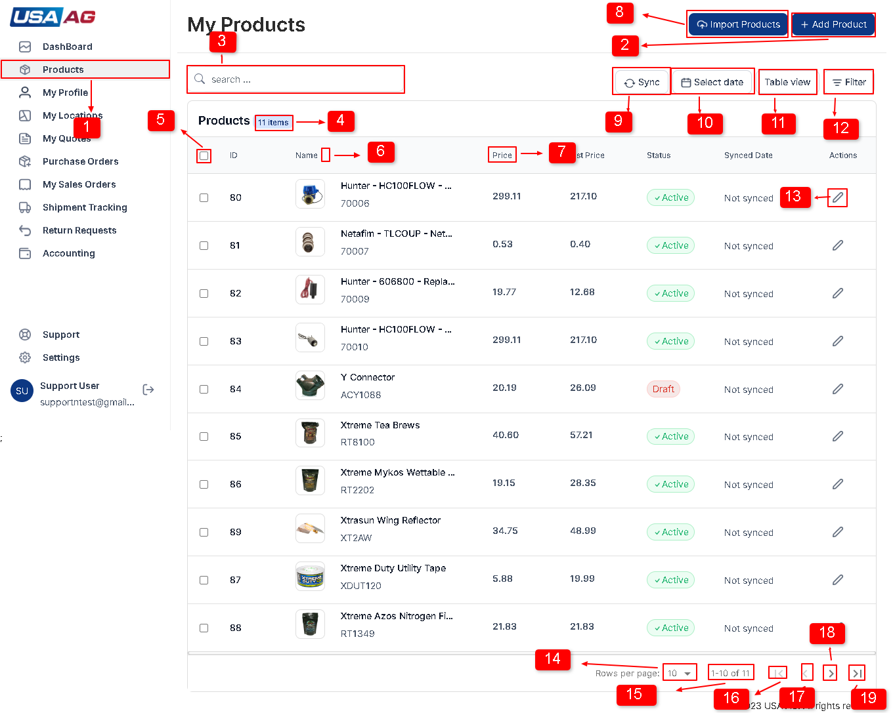  
Fig: 1 [Product list page.](http://192.168.1.168:3000/vendor/support/products)

**Adding an new product?**

**Steps to add an product**

**1**

After logging in, click on the "Products" option in the right sidebar. Refer to [Figure 1](http://192.168.1.168:3000/vendor/support/products), and locate the option marked with point 1

**2**

You will be redirected to the products page. On this page, you can see a list of your added products. At the top right of the products page, locate the "Add Product" option marked as point 2 in [Figure 1](http://192.168.1.168:3000/vendor/support/products).

**3**

Click on the "Add Product" option to navigate to the Add Product page. Here, you will find a form with several fields to fill out shown in [Figure 2](http://192.168.1.168:3000/vendor/support/products). The fields on the Add Product form include:

* Title: This is a required field and should be of text type.
* Description: An editor field that allows you to enter HTML content.
* Type: A text field.
* Brand: A text field.
* SKU: A text field that is not available if the product has variants added.
* Price: A number field that is not available if the product has variants added.
* List Price: A number field that is not available if the product has variants added.
* Images: An image field. The first image set here will be shown on the product listing. You can add, remove, or swap images. The size of each image should be below 1MB, and only allowed image types are accepted. You can add up to 10 images. Shown in [Figure 2, 3](http://192.168.1.168:3000/vendor/support/products).
* Meta Title: A text field.
* Meta Description: A text field.
* Tags: A tags field. After entering text in the field, press Enter to add a tag. Tags must be unique.
* Is Active: A switch field.
* Variant Title: A unique and required field to add a variant. Shown in [Figure 4,5](http://192.168.1.168:3000/vendor/support/products)
* Variant SKU: A text field for the variant.Shown in [Figure 4,5](http://192.168.1.168:3000/vendor/support/products)
* Variant Price: A number field for the variant price.Shown in [Figure 4,5](http://192.168.1.168:3000/vendor/support/products)
* Variant List Price: A number field for the variant list price.Shown in [Figure 4,5](http://192.168.1.168:3000/vendor/support/products)
* Variant Image: An image field for the variant. You can only add one image, and the maximum image size is 1MB.Shown in [Figure 4,5](http://192.168.1.168:3000/vendor/support/products)

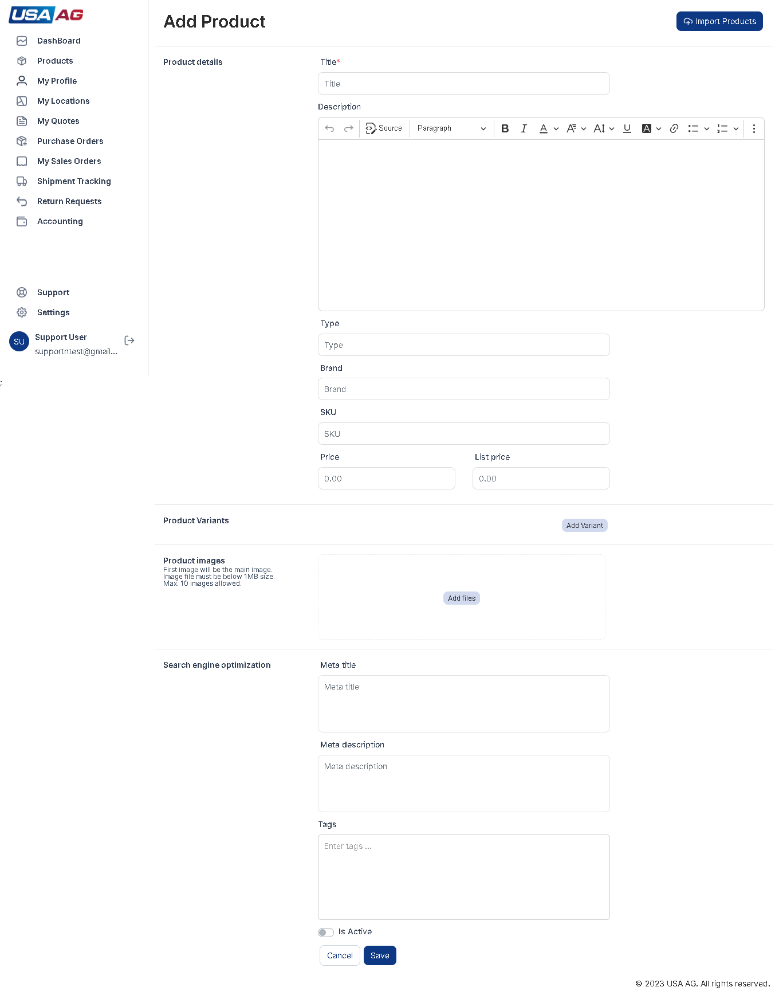  
Fig: 2 [Add product form page.](http://192.168.1.168:3000/vendor/support/products)

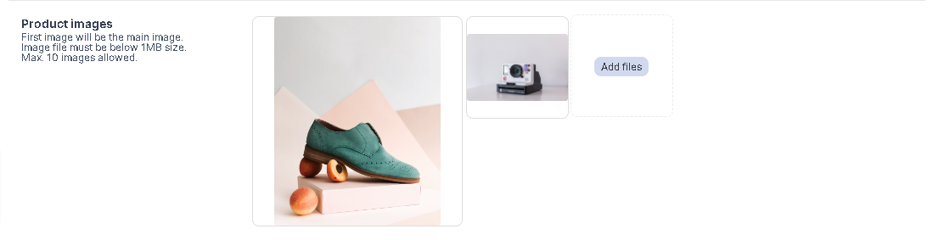  
Fig: 3 [Add Variant image.](http://192.168.1.168:3000/vendor/support/products)

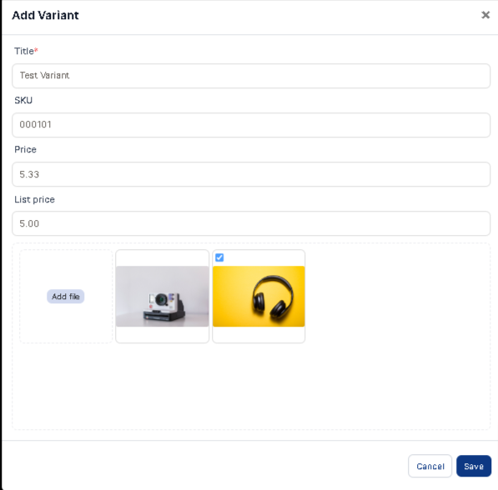  
Fig: 4 [Add Variant image.](http://192.168.1.168:3000/vendor/support/products)

**4**

Fill the fields in form with information like shown in Shown in [Figure 2, 3, 4](http://192.168.1.168:3000/vendor/support/products)

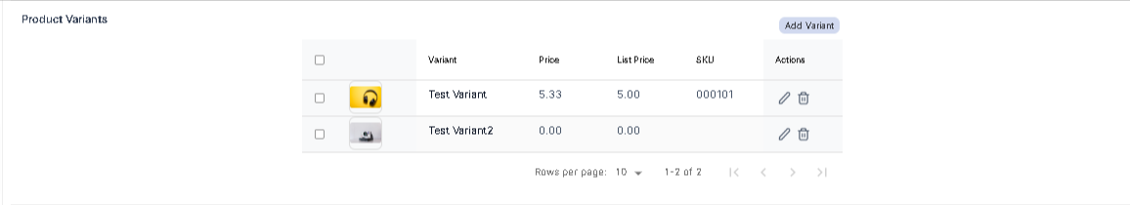  
Fig: 5 [Variant list image.](http://192.168.1.168:3000/vendor/support/products)

**5**

After filling out the necessary information, click the "Save" option to add the product. If product is added successful it add product to products list and if there is error it will show error in error box right top corner of page as shown in [Figure 6](http://192.168.1.168:3000/vendor/support/products).

Fig: 6 [Save and Cancel button image.](http://192.168.1.168:3000/vendor/support/products)

**6**

If you decide to cancel, all the entered data in the fields will be removed, and you will be redirected to the product listing page shown in [Figure 6](http://192.168.1.168:3000/vendor/support/products).

**Edit an product?**

**Steps to edit an product**

**1**

In product listing page you can see edit button in product row marked as point 13 in [Figure 1](http://192.168.1.168:3000/vendor/support/products) .On click you will be redirected to Edit product page.

**2**

You will be redirected to the product's edit page, where you can make changes to the product details.Show in [Figure 7](http://192.168.1.168:3000/vendor/support/products)

**3**

On the edit page, you will find a form with various fields to update the product information. The fields are described in "Adding an Product" step 3.

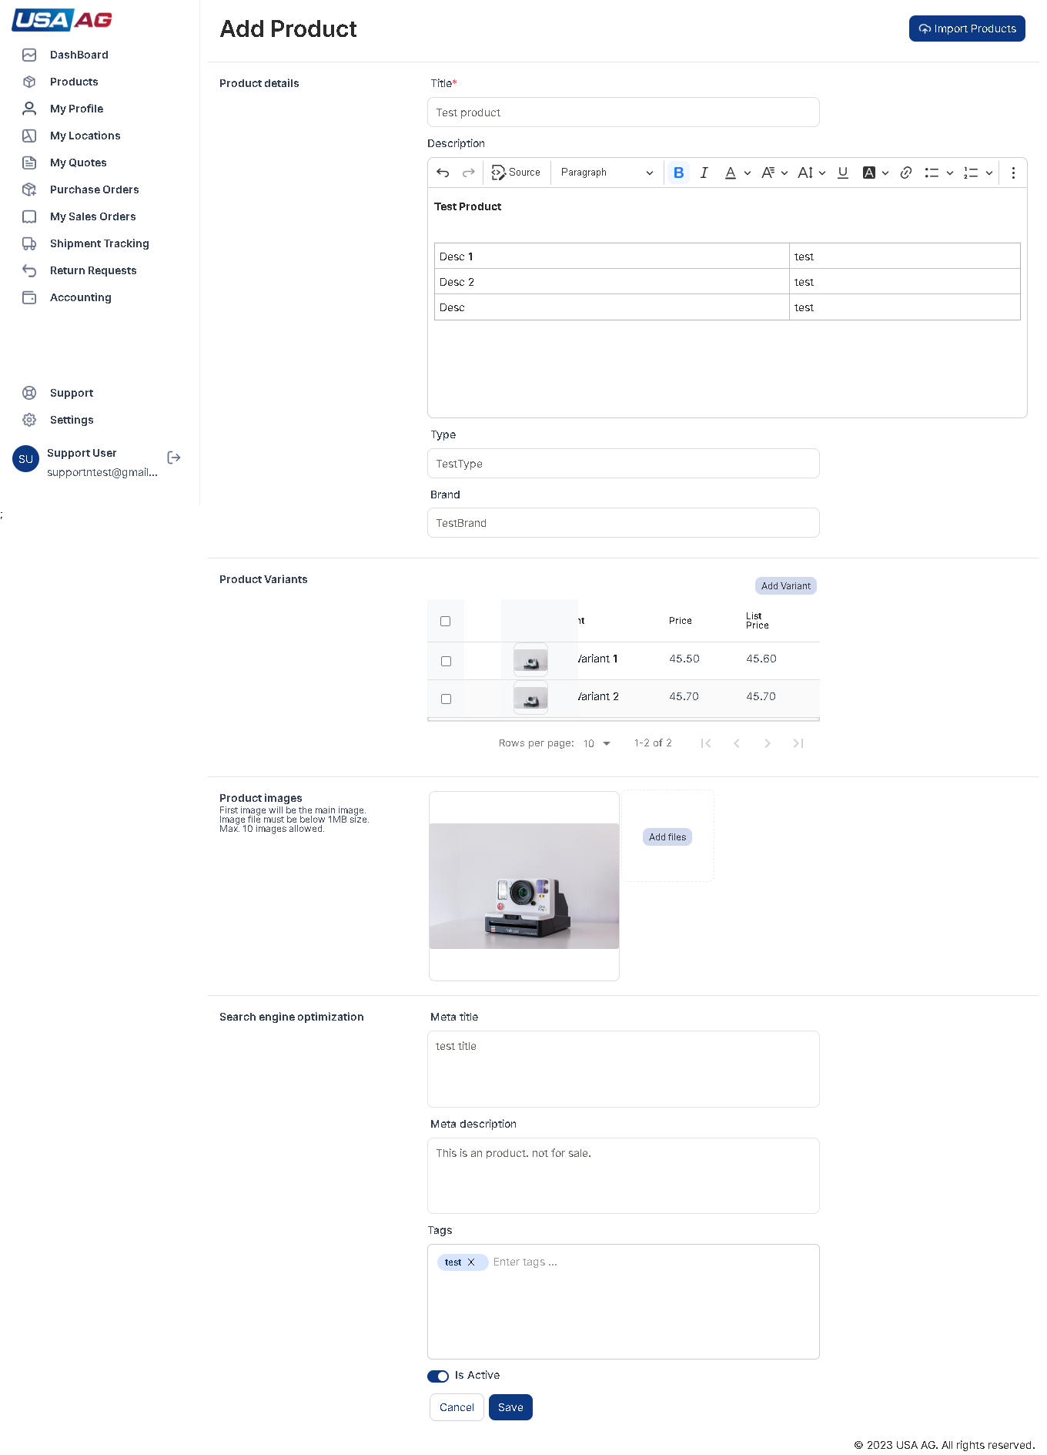  
Fig: 7 [Product list page.](http://192.168.1.168:3000/vendor/support/products)

**4**

Make the necessary modifications to the product details within the form.

**5**

Once you have finished editing the product, click the "Update" option to save the changes.

**6**

If you decide to discard the changes and revert to the original product details, you can click the "Cancel" option. This will discard any modifications made and redirect you back to the product listing page.

**Location Listing?**

**In the My location listing page, you will find several elements as indicated by the numbered points in the**[**Figure 1**](http://192.168.1.168:3000/vendor/support/locations)**. Here is a description of each point:**

1. This button represents the My location list page.
2. Header in listing page.
3. The search bar allows you to filter location based on their warehouse names.
4. The number indicates the total count of location in the list.
5. Check box to select all table data show for process like deletion.
6. These icons are used for sorting the table based on the column name when clicked.
7. The checkbox allows you to select location single selection.
8. This button redirects you to the import locations page.
9. Clicking this button will redirect you to the location add form page.
10. This button opens a modal that enables you to filter location based on specific dates. as shown in [Figure 2](http://192.168.1.168:3000/vendor/support/locations).
11. Clicking this button opens a modal that allows you to select which columns to display in the table.as shown in [Figure 3](http://192.168.1.168:3000/vendor/support/locations).
12. This button opens a modal that enables you to filter data using various options specific to each column.
13. Show button for view location page.
14. Show button for edit location page.
15. This dropdown menu lets you choose the number of locations to be displayed per page.
16. This number represents the current range of locations being shown out of the total count.
17. Clicking this button takes you to the first page of the location list.
18. This button takes you to the previous page of the location list.
19. This button takes you to the next page of the location list.
20. This button takes you to the last page of the location list.
21. The column name represents the specific attribute or characteristic of the location displayed in the table.
22. This point indicates list table header.

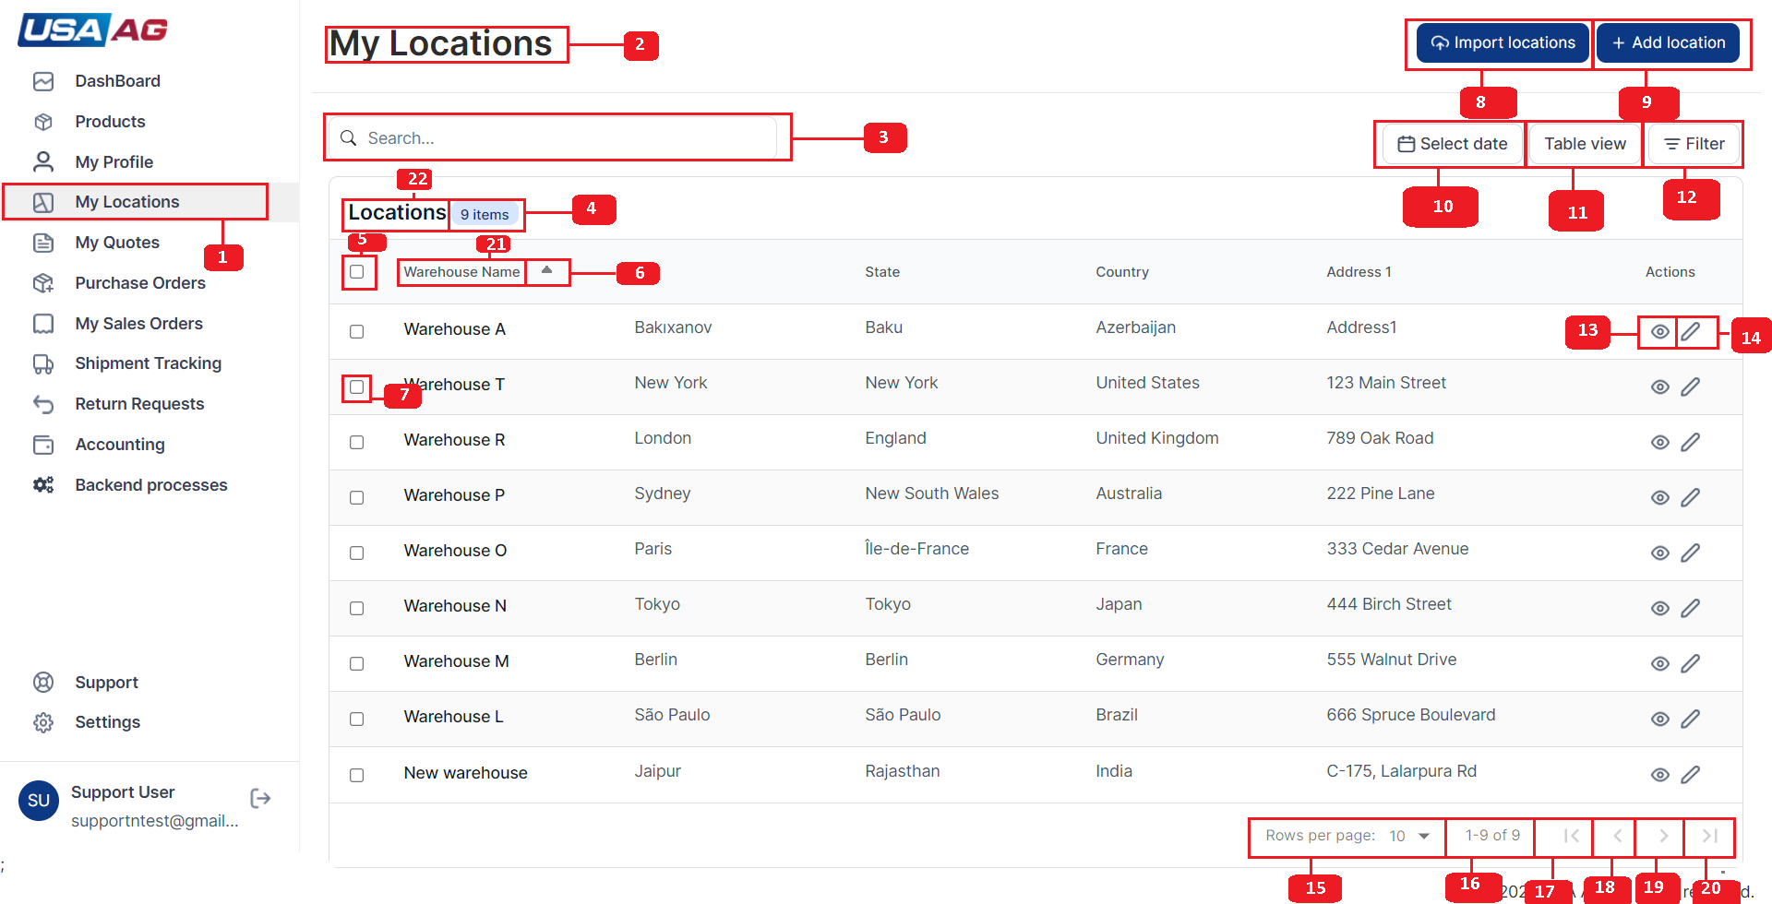  
Fig: 1 [Location list page.](http://192.168.1.168:3000/vendor/support/locations)

**Adding an new location?**

**Steps to add an location**

**1**

Click on the "My Locations" option in the right sidebar. Refer to [Figure 1](http://192.168.1.168:3000/vendor/support/locations), and locate the option marked with point 1

**2**

You will be redirected to the My locations page. On this page, you can see a list of your added Warehouse locations. At the top right of the My locations page, locate the "Add Location" option marked as point 2 in [Figure 1](http://192.168.1.168:3000/vendor/support/locations).

**3**

Click on the "Add Location" option to navigate to the Add Location page. Here, you will find a form with several fields to fill out shown in [Figure 4](http://192.168.1.168:3000/vendor/support/locations). The fields on the Add Location form include:

* Warehouse name: This is a required field and should be of text type.
* Address line1: This is a required field and should be of text type.
* Address line2: A text field.
* Country: A dropdown select list.In default it shows option "select country".This field is required.
* State: A dropdown select list it will load after selection of Country field.In default it shows option "select state".This field is required.
* City: A dropdown select list it will load after selection of State field.In default it shows option "select city".This field is required.
* Zip Code: An required text field.

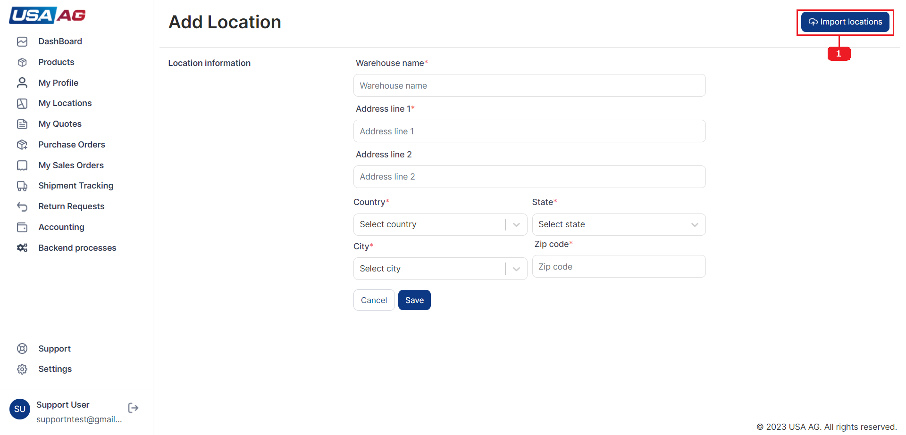  
Fig: 4

**4**

Fill the fields in form with information.

**5**

After filling out the necessary information, click the "Save" option to add the location. If location is added successfully it add location to location list and if there is error it will show error in error box right top corner of page.

**6**

If you decide to cancel, all the entered data in the fields will be removed, and you will be redirected to the location listing page shown in [Figure 1](http://192.168.1.168:3000/vendor/support/locations).

**Edit an location?**

**Steps to edit an location**

**1**

In My location listing page you can see edit button in location row marked as point 14 in [Figure 1](http://192.168.1.168:3000/vendor/support/locations) .On click you will be redirected to Edit location page.

**2**

You will be redirected to the location's edit page, where you can make changes to the location details.Show in [Figure 5](http://192.168.1.168:3000/vendor/support/locations).

**3**

On the edit page, you will find a form with various fields to update the warehouse location information. The fields are decribed in "Adding an Location" step 3.

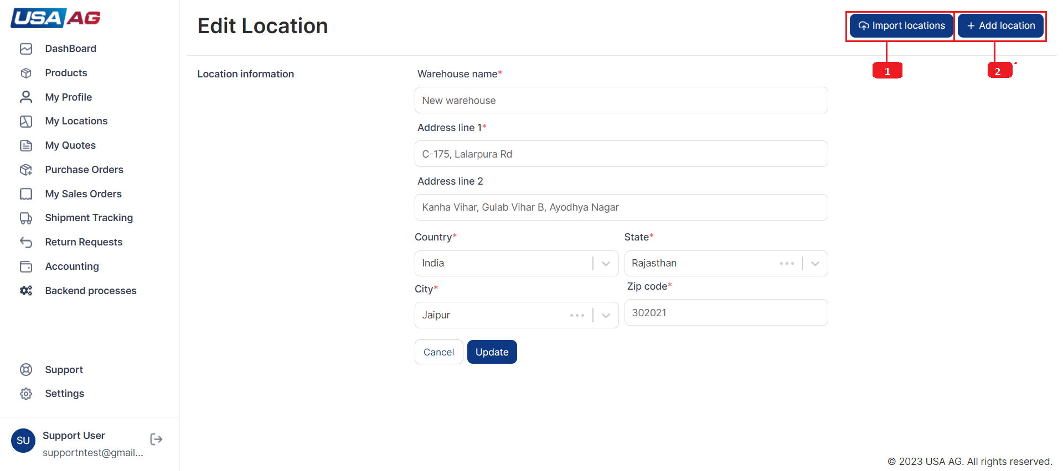  
Fig: 5

**4**

Make the necessary modifications to the location details within the form.

**5**

Once you have finished editing the location, click the "Update" option to save the changes.

**6**

If you decide to discard the changes and revert to the original location details, you can click the "Cancel" option. This will discard any modifications made and redirect you back to the My Locations listing page.

**View location?**

**In the view location page, you will find several elements as indicated by the numbered points in the**[**Figure 6**](http://192.168.1.168:3000/vendor/support/locations)**. Here is a description of each point:**

1. This button has navigation to import location page.
2. This button redirects to Add new location form page.
3. This points indicates the Warehouse name.It is also an link to see location map on new tab.as shown in [Figure 7](http://192.168.1.168:3000/vendor/support/locations).
4. This "Locations" buttons redirects to location listing page.
5. This point indicates button to edit the viewing location on click it open edit location form.

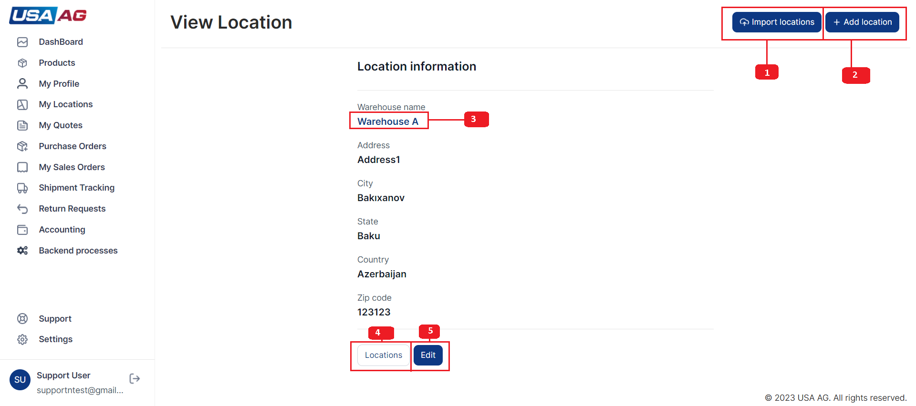  
Fig: 6

**How to bulk imports from CSV file?**

**Steps to bulk imports items from CSV file**

**1**

If you click on "Import items"("Import products") [Figure 1](http://192.168.1.168:3000/vendor/support/imports). It redirects to import page of clicked item type.

  
Fig: 1 [Import button](http://192.168.1.168:3000/vendor/support/imports)

**2**

Import page is shown in In [Figure 2](http://192.168.1.168:3000/vendor/support/imports). some points are marked detailed below:

1. Shows button that redirects to Add item("product") form page.
2. Link to opens video tutorial in new tab for how to import items.
3. Download link for downloading sample CSV file.
4. Dropdown to select type of delimiter for uploading CSV file.
5. Link that open modal to select CSV file.
6. Button that opens modal to upload CSV to server.
7. Button to cancel importing process
8. Shows the selected CSV file for import process.
9. Shows the button to remove selected CSV file.

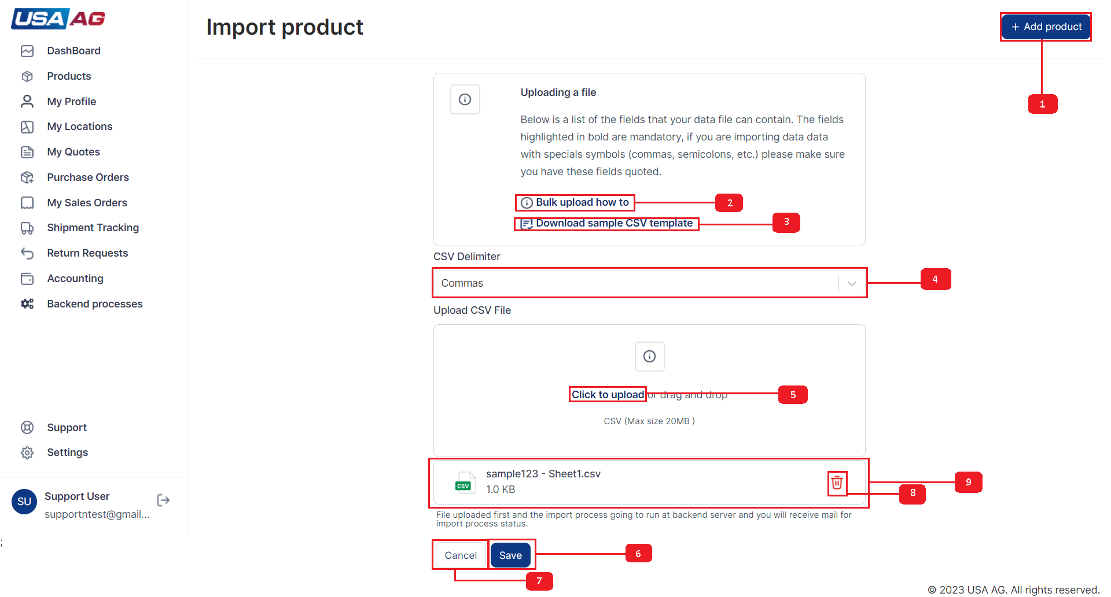  
Fig: 2 [Import page](http://192.168.1.168:3000/vendor/support/imports)

**3**

Select delimiter from dropdown for file.

**4**

Select CSV file to upload.

**5**

Click on Save button.

**6**

On save button click it open modal to start upload file as shown in [Figure 3](http://192.168.1.168:3000/vendor/support/imports).

1. First point on figure 3 show file name and its size.
2. Second point shows button to close upload modal.
3. Third point show upload button.On click it starts upload process.Progress of upload file can be seen in progress bar under file size.

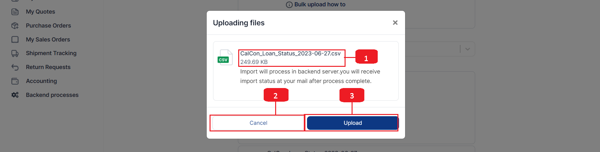  
Fig: 3 [Upload file](http://192.168.1.168:3000/vendor/support/imports)

**7**

Modal shows error if error from server or gets import process start message. Import process is going to be run in backend. Backend process are logged in Backend processes logs. After completion items are gone listed in item list and mail sent on email linked to account. Email shows descriptive report on import results.

**Backend process Listing?**

**In the Backend processes listing page, you will find several elements as indicated by the numbered points in the**[**Figure 1**](http://192.168.1.168:3000/vendor/support/backend-processes)**. Here is a description of each point:**

1. This button represents the Backend processes list page.
2. Shows header for Backend process list page.
3. The search bar allows you to filter Backend processes based on their process names.
4. Shows table list heading.
5. The number indicates the total count of Backend processes in the list.
6. The column name represents the specific attribute or characteristic of the Backend processes displayed in the table.
7. These icons are used for sorting the table based on the column name when clicked.
8. Point 8 shows status for process.status are - Pending, Running, Completed, Failed, Paused and Cancelled.
9. This button opens a modal that enables you to filter Backend processes based on specific dates.as shown in [Figure 2](http://192.168.1.168:3000/vendor/support/backend-processes).
10. Clicking this button opens a modal that allows you to select which columns to display in the table.as shown in [Figure 3](http://192.168.1.168:3000/vendor/support/backend-processes).
11. This button opens a modal that enables you to filter data using various options specific to each column. as shown in [Figure 4](http://192.168.1.168:3000/vendor/support/backend-processes).
12. Clicking this button opens you to the view process modal for the selected Backend process.
13. This dropdown menu lets you choose the number of Backend processes to be displayed per page.
14. This number represents the current range of Backend processes being shown out of the total count.
15. Clicking this button takes you to the first page of the Backend processes list.
16. This button takes you to the previous page of the Backend processes list.
17. This button takes you to the next page of the Backend processes list.
18. This button takes you to the last page of the Backend processes list.

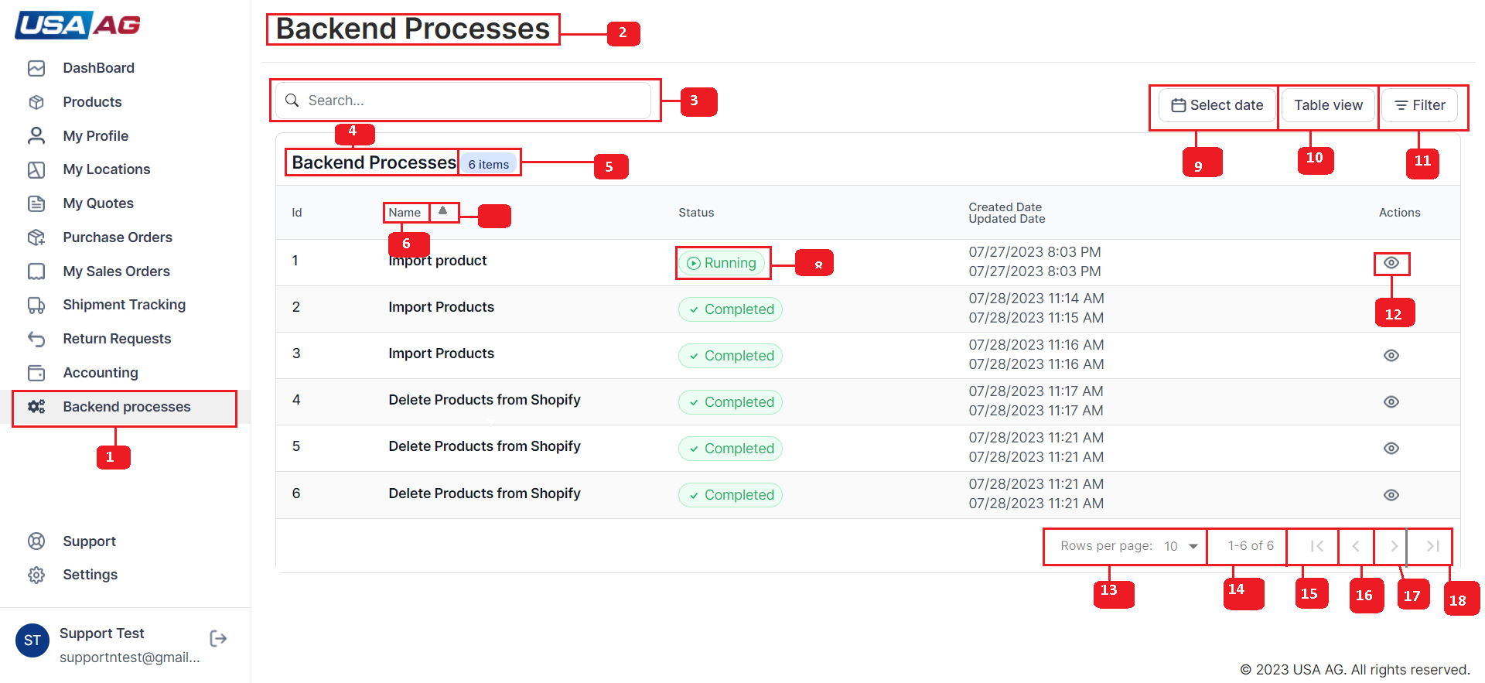  
Fig: 1 [Backend process list page.](http://192.168.1.168:3000/vendor/support/backend-processes)

**View Backend process?**

**In the view process modal, you will find several elements as indicated by the numbered points in the**[**Figure 5**](http://192.168.1.168:3000/vendor/support/backend-processes)**. Here is a description of each point:**

1. Shows name of process.
2. Process status badge.
3. Message.
4. Error occurred while process.
5. Dates: created date and updated date.

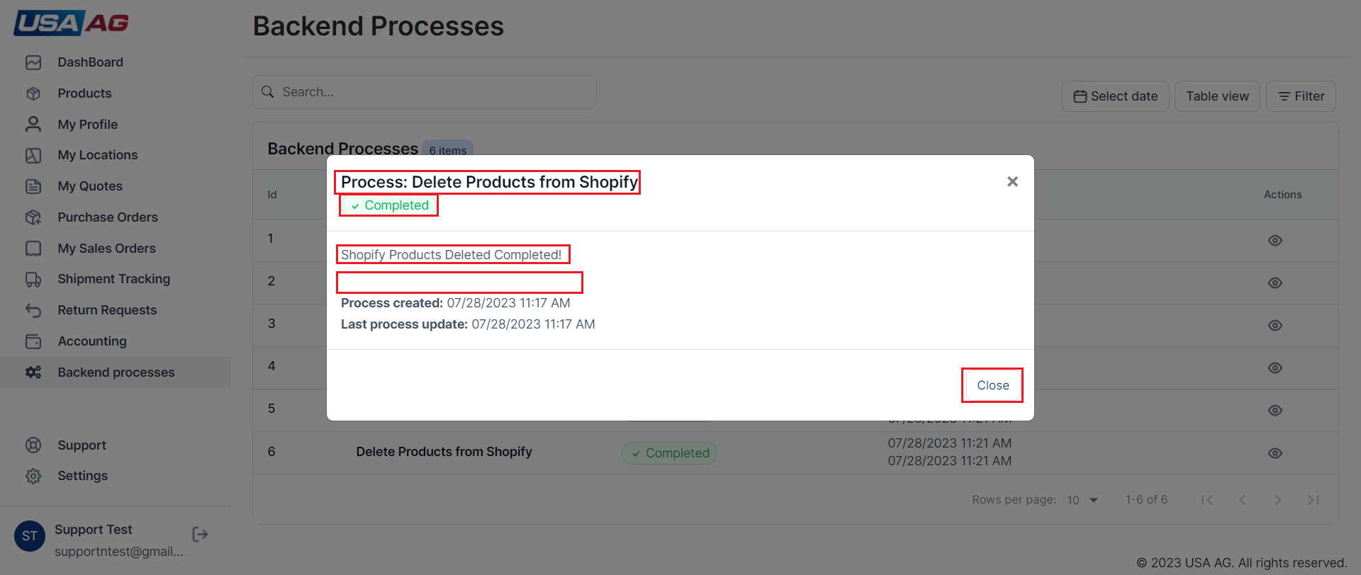  
Fig: 5 [View process.](http://192.168.1.168:3000/vendor/support/backend-processes)

**Purchase orders Listing?**

**Purchase order listing styling is same as location listing you can refer to (**[**location listing**](http://192.168.1.168:3000/vendor/support/purchase-orders)**) with different columns, actions and filters explained below:**

1. Purchase order listing table has columns POId(Purchase order id),PO Name(Purchase order name),Status,Dates and Actions.
2. Purchase order listing page has two actions PO(Navigation to purchase order details page - referred as point 1 in [Figure 1](http://192.168.1.168:3000/vendor/support/purchase-orders)) and SO (Navigation to Sales order details page related to PO referred as point 2 in [Figure 1](http://192.168.1.168:3000/vendor/support/purchase-orders)).
3. Purchase order listing page has Search , Created Date and Status filters as shown in [Figure 1 and 5](http://192.168.1.168:3000/vendor/support/purchase-orders).

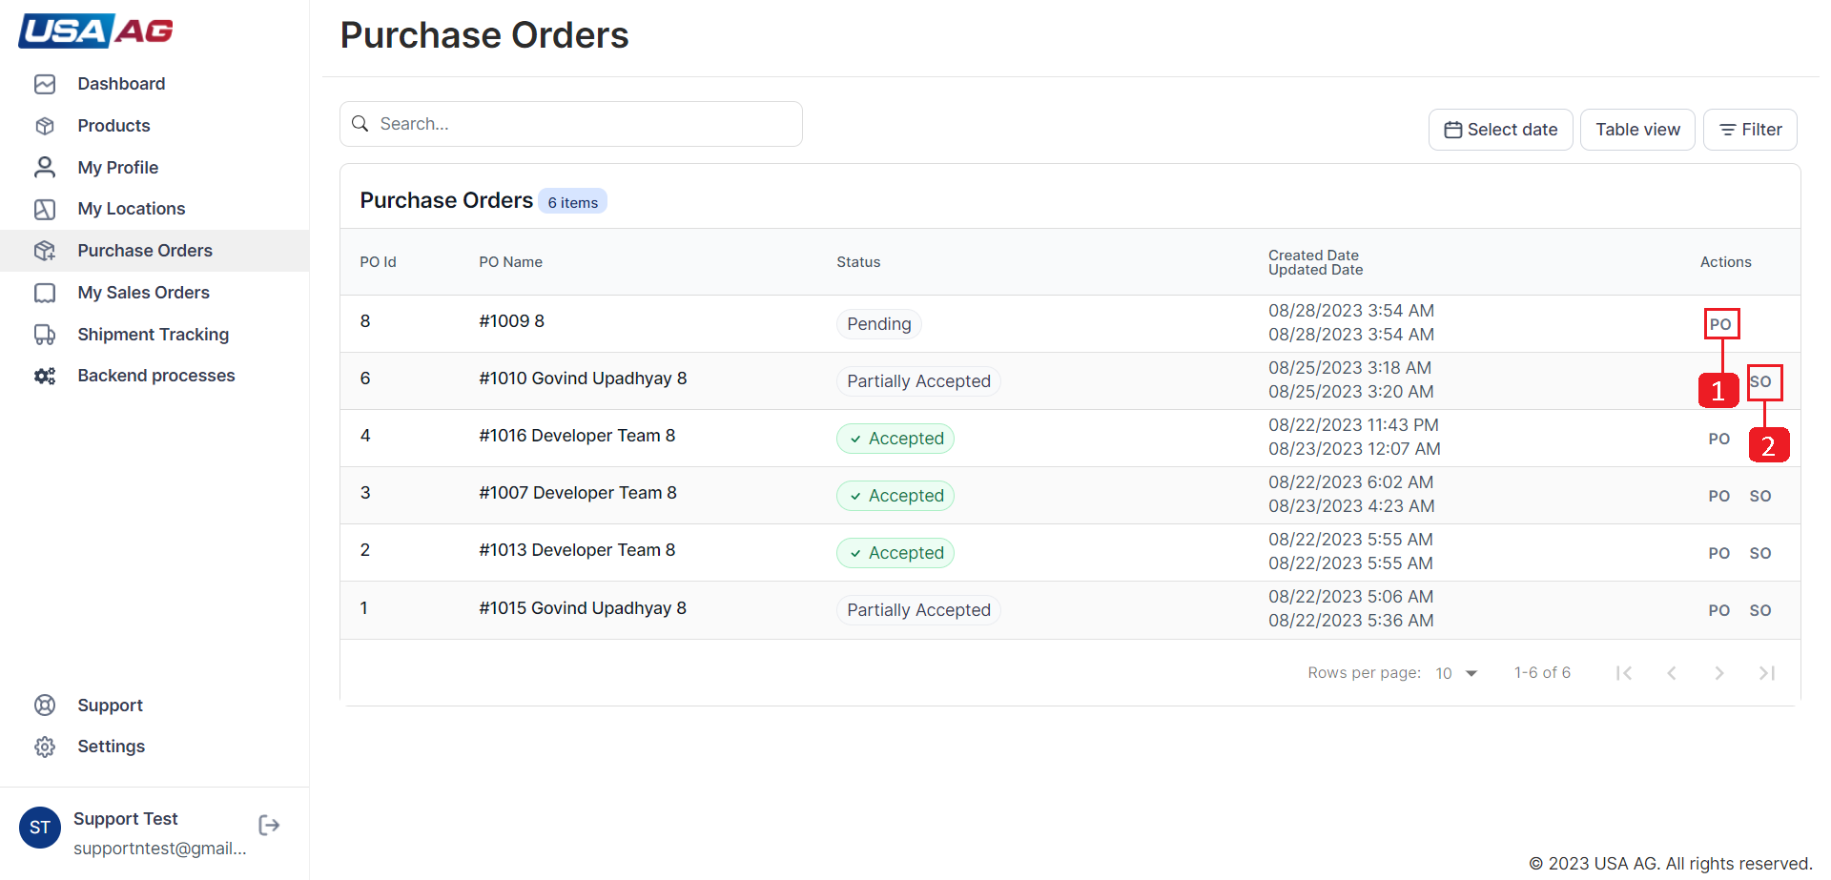  
Fig: 1 [Purchase order list page.](http://192.168.1.168:3000/vendor/support/purchase-orders)

**View purchase order?**

**In the View purchase order page, you will find several elements as indicated by the numbered points in the**[**Figure 2, 3 and 4**](http://192.168.1.168:3000/vendor/support/purchase-orders)**. Here is a description of each point:**

In [Figure 2](http://192.168.1.168:3000/vendor/support/purchase-orders):

1. Shows Purchase order id.
2. Shows Purchase order name.
3. Shows Purchase order created date.
4. Shows card for showing customer details like email.
5. Shows Billing address.
6. Shows Table for purchase order items that are not accepted by vendor.
7. Shows Shipping address.
8. Shows input to select item quantity to accept Purchase order items.Min 1 and Max upto quantity required.
9. Shows multiplication of committed quantity and price as Sub total.

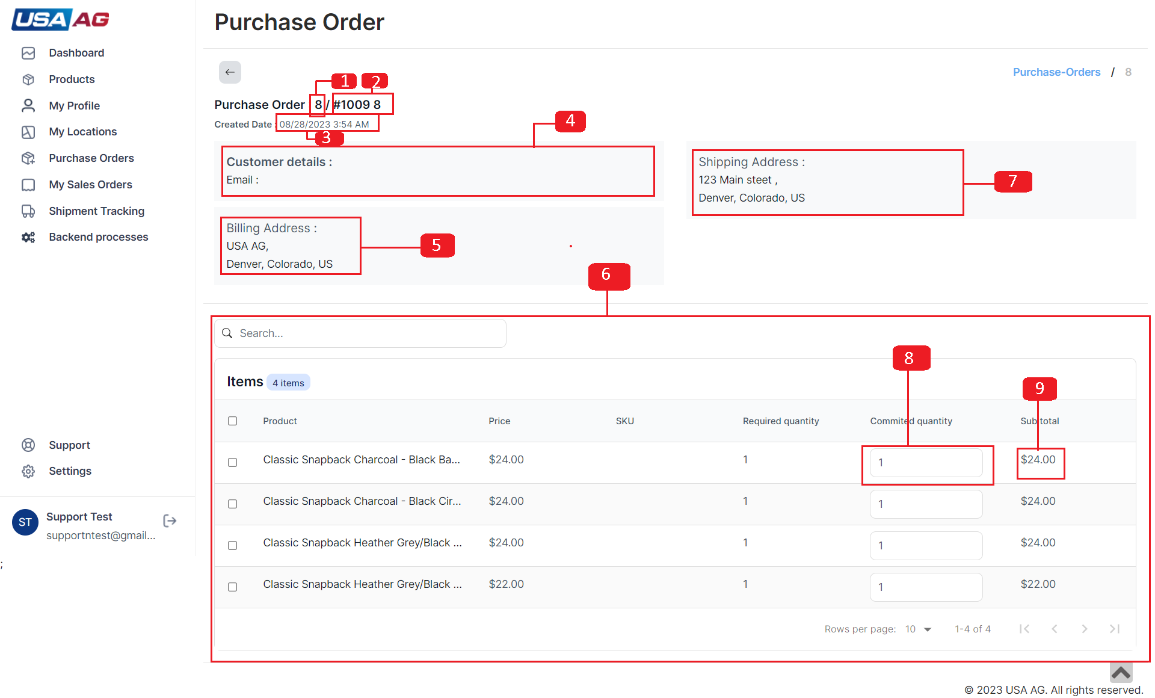  
Fig: 2 [Purchase order details page.](http://192.168.1.168:3000/vendor/support/purchase-orders)

In [Figure 3](http://192.168.1.168:3000/vendor/support/purchase-orders):

1. Checkbox to select item.
2. Button to accept selected items in purchase order. It appears if only min 1 item is selected from list.
3. Shows input to select item quantity to accept Purchase order items.Min 1 and Max upto quantity required.
4. Shows multiplication of committed quantity and price as Sub total.
5. Shows list of selected items in Purchase order pending list.

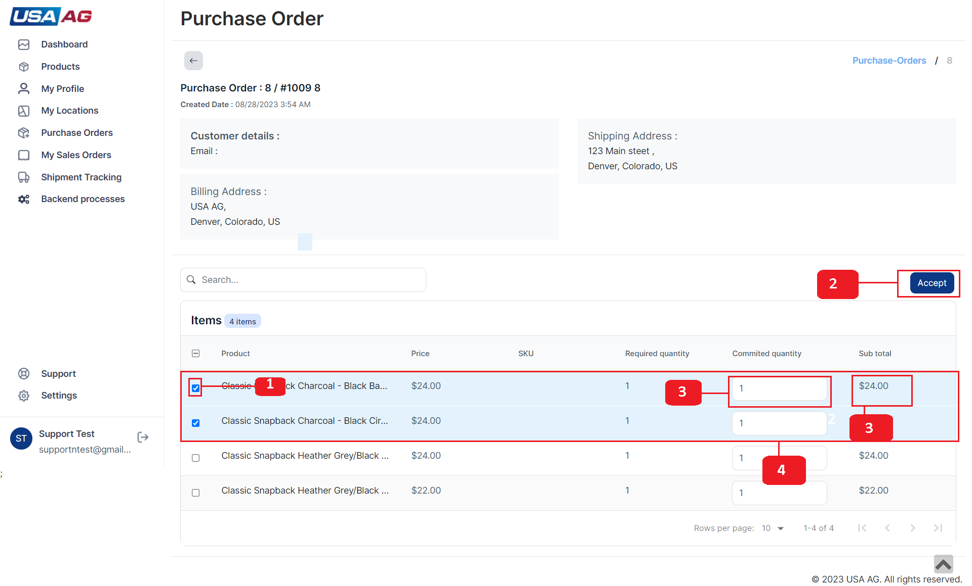  
Fig: 3 [Purchase order details page with selected items.](http://192.168.1.168:3000/vendor/support/purchase-orders)

In [Figure 4](http://192.168.1.168:3000/vendor/support/purchase-orders) pointed point shows list of approved items having columns like Item name, price, sku, quantity and subtotal. If item is accepted it will generate sales order with corresponding details from purchase order.

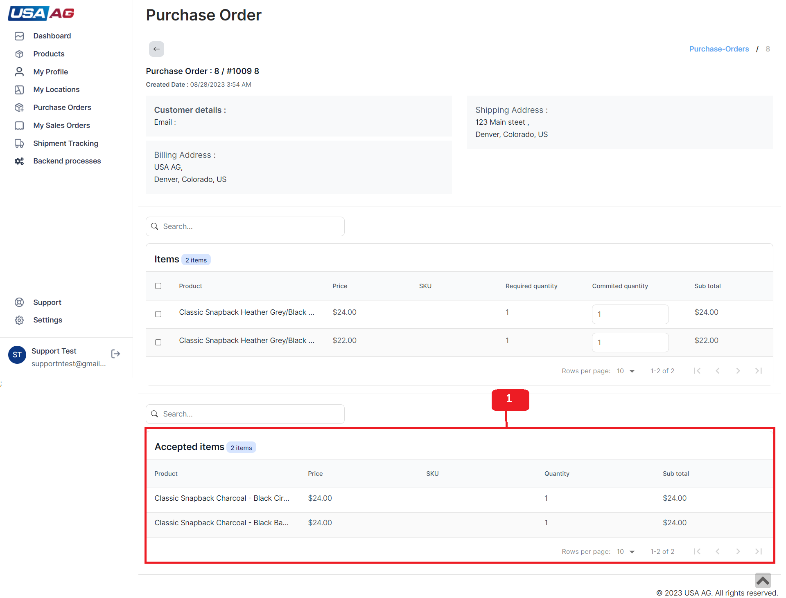  
Fig: 4 [Purchase order details page with approved items.](http://192.168.1.168:3000/vendor/support/purchase-orders)

**Accept Purchase order items?**

**Steps to accept items from purchase order pending items and generate sales order:**

**1**

Change committed quantity as required in range of required quantity as shown in[Figure 2](http://192.168.1.168:3000/vendor/support/purchase-orders)

**2**

Select Items as required from pending items by clicking checkboxes. If the selected no of checkboxes are more than 0 it will make Accept button appear.

**3**

On clicking Accept button it will generate so with corresponding purchase order details.If the so generated the accepted item will appear in PO details page. Also navigation button for SO also appear in PO listing and sales order will be listed in Sales order listing page.

**Sales order listing?**

**Sales order listing styling is same as location listing you can refer to (**[**location listing**](http://192.168.1.168:3000/vendor/support/sales-orders)**) with different columns, actions and filters explained below:**

1. Sales order listing table has columns SOId(Sales order id), POId(referenced Purchase order id), SO Name(Sales order name), Status, Pending Items, Fulfilled Items, Total, Dates and Actions.
2. Sales order listing page has one action to view sales order[Figure 1](http://192.168.1.168:3000/vendor/support/sales-orders).
3. Sales order listing page has Search , Created Date and Status filters as shown in [Figure 1 and 6](http://192.168.1.168:3000/vendor/support/sales-orders).

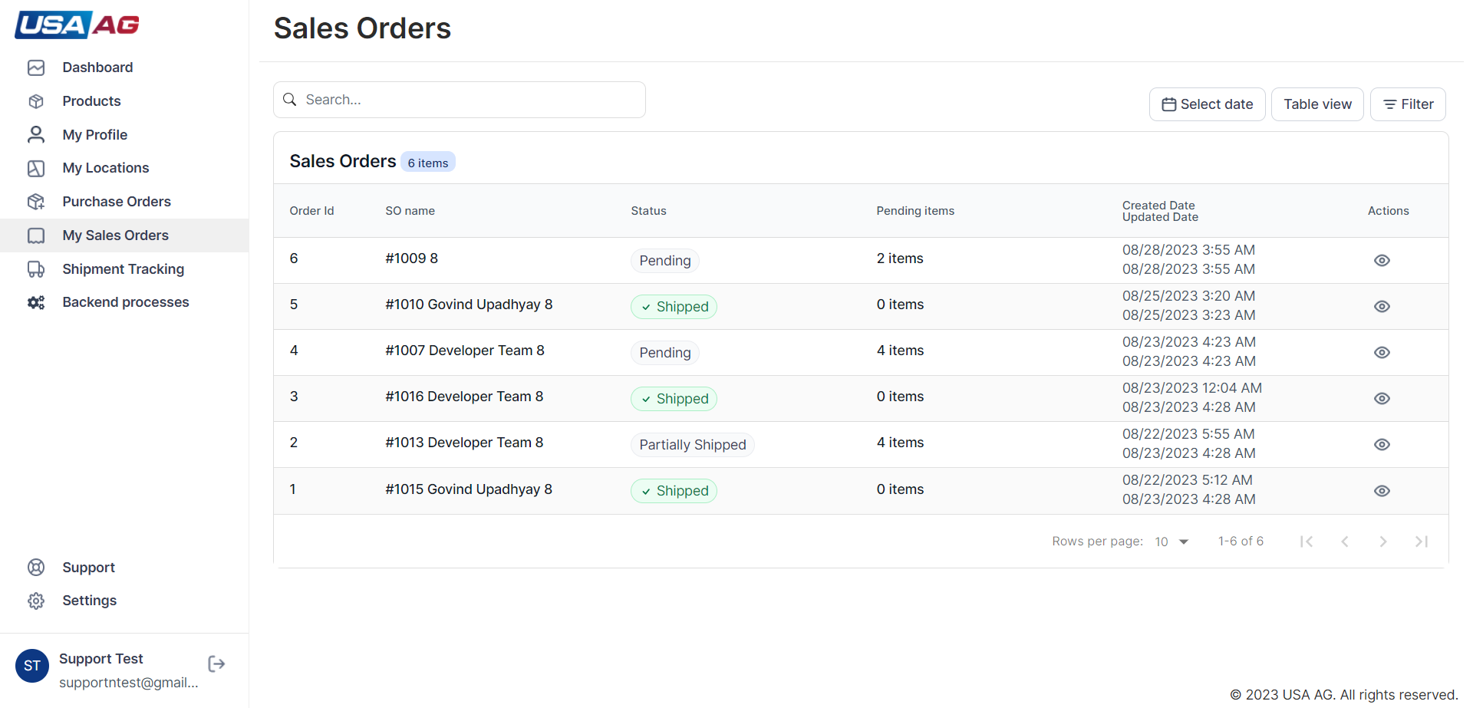  
Fig: 1 [Purchase order list page.](http://192.168.1.168:3000/vendor/support/sales-orders)

**View Sales order?**

**In the View Sales order page, you will find several elements as indicated by the numbered points in the**[**Figure 2 and 5**](http://192.168.1.168:3000/vendor/support/sales-orders)**. Here is a description of each point:**

In [Figure 2](http://192.168.1.168:3000/vendor/support/sales-orders):

1. Shows Sales order id.
2. Shows Sales order name.
3. Shows Sales order created date.
4. Shows Billing address.
5. Shows Shipping address.
6. Shows card for showing customer details like email.
7. Shows Button to goto Unfulfilled items.
8. Shows Status for sales order Pending, Partially shipped and Shipped.
9. Button to Create shipment for selected items in sales order. It appears if only min 1 item is selected from list. Refer to [Create new shipment?](http://192.168.1.168:3000/vendor/support/sales-orders) for more details.
10. Shows input to select item quantity to Create Shipment for items.Min 1 and Max upto quantity required.
11. Shows multiplication of committed quantity and price as Sub total.
12. Checkbox to select item.
13. Shows Customer note.
14. Shows staff only note.

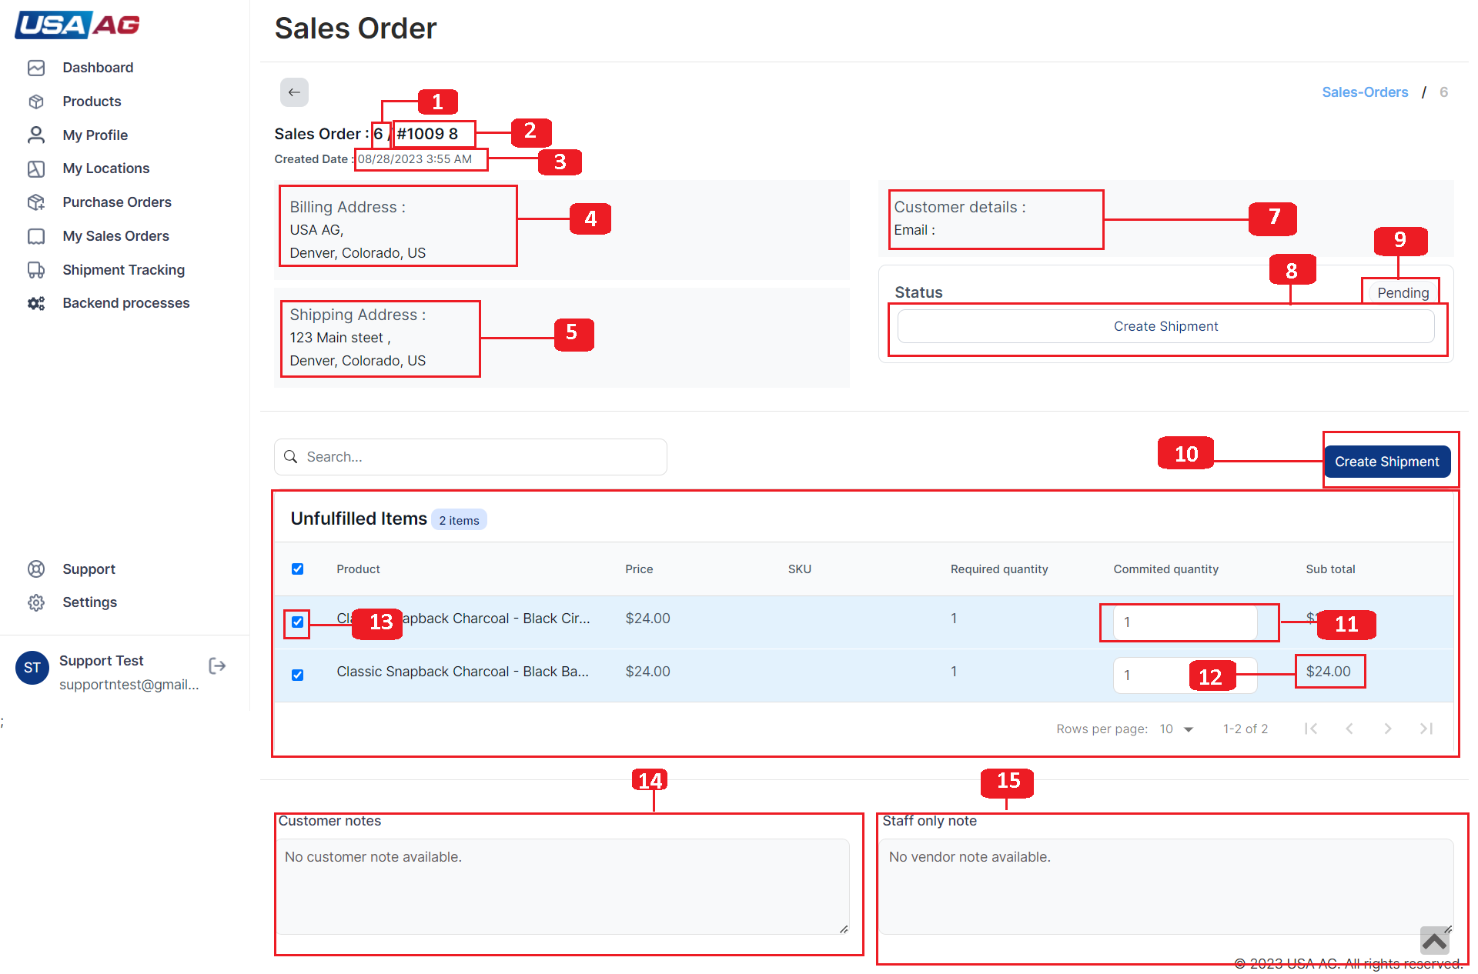  
Fig: 2 [Sales order details page.](http://192.168.1.168:3000/vendor/support/sales-orders)

In [Figure 4](http://192.168.1.168:3000/vendor/support/sales-orders):

1. Shows button to goto shipments appears only if there is shipment is created.
2. Shows Shipment details.For more details refer to [View shipment?](http://192.168.1.168:3000/vendor/support/sales-orders)
3. Shows button to Change status from picked to shipped it will only appear if the status of shipment is picked. On click it opens Mark shipment as shipped Modal for more details refer to [Change shipment status(Mark as shipped)?](http://192.168.1.168:3000/vendor/support/sales-orders)

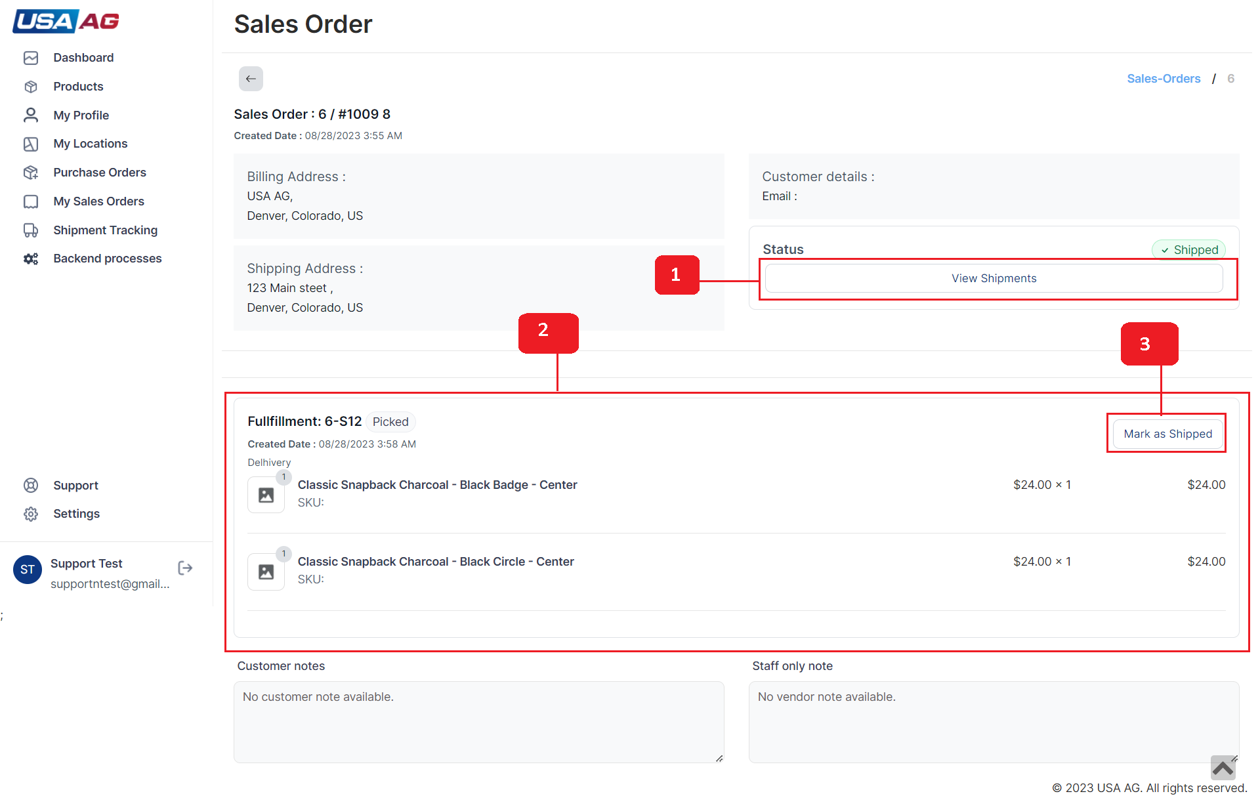  
Fig: 5 [Sales order details page with shipments.](http://192.168.1.168:3000/vendor/support/sales-orders)

**Create new shipment?**

**Steps to create new shipment:**

**1**

Change committed quantity as required in range of required quantity as shown in[Figure 2](http://192.168.1.168:3000/vendor/support/sales-orders)

**2**

Select Items as required from unfulfilled items by clicking checkboxes. If the selected no of checkboxes are more than 0 it will make Create shipment button appear.

**3**

On clicking Create shipment button it will open New Shipment modal with fields Location, Shipment status(Picked, Shipped), Carrier, Comments ,Tracking no(status shipped), Tracking url(status shipped), Shipment cost(status shipped) and Send mail to customer(status shipped) as shown in[Figure 3 and 4](http://192.168.1.168:3000/vendor/support/sales-orders). Fields marked with * are required. Tracking url must start with "http://" or "https://",

**4**

After Filling form and clicked on Save it will create Shipment related to sales order with selected items. Shipment also appear in Shipment listing.

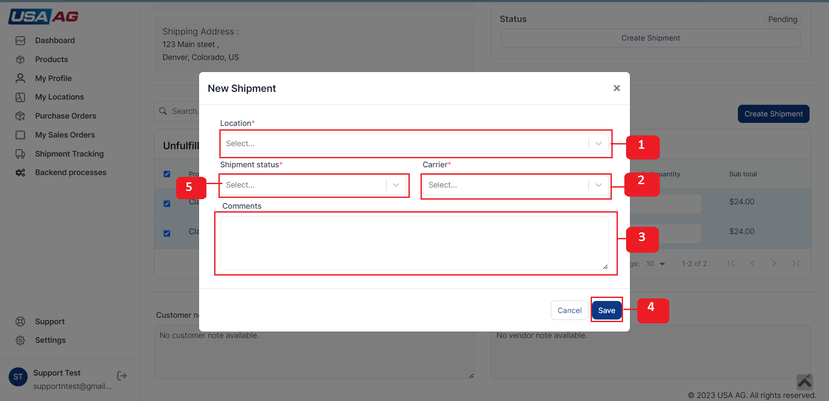  
Fig: 3 [New Shipment Modal.](http://192.168.1.168:3000/vendor/support/sales-orders)

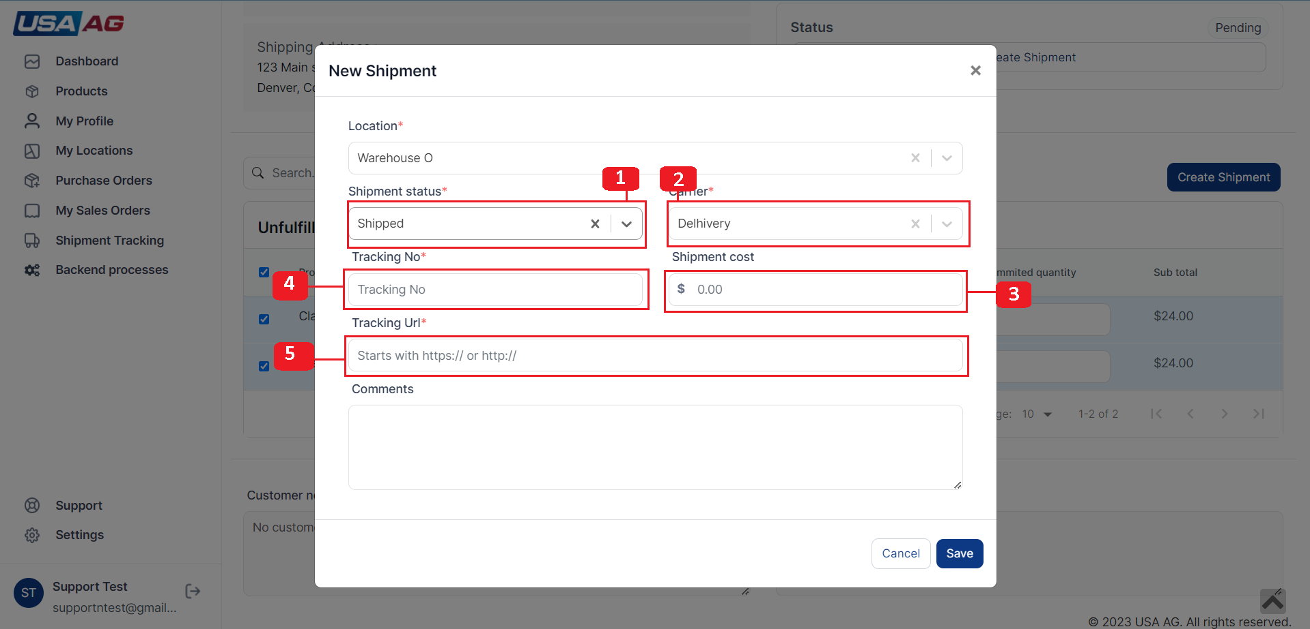  
Fig: 4 [New Shipment Modal with selected shipped status.](http://192.168.1.168:3000/vendor/support/sales-orders)

**Change shipment status(Mark as shipped)?**

**Shipment "Mark as shipped" and Sales order "Mark as shipped" are same so you can refer to (**[**Change shipment status(Mark as shipped)?**](http://192.168.1.168:3000/vendor/support/sales-orders)**) in shipments.**

**Shipment Listing?**

**Shipment listing styling is same as location listing you can refer to (**[**location listing**](http://192.168.1.168:3000/vendor/support/shipments)**) with different columns, actions and filters explained below:**

1. Shipment listing table has columns Shipment Id, SO Id, Shipment Name, Tracking Number, Status, Shipping Cost, Tracking URL, Carrier, Items, Dates, Location and Actions.
2. Shipment listing page has three actions View Shipment(navigation to details page), Invoice(opens invoice generate modal for shipment) and Mark as Shipped(open modal to change status to shipment).
3. Shipment listing page has Search , Created Date, Carrier, Location, Send notification to customer and Status filters as shown in [Figure 2 and 6](http://192.168.1.168:3000/vendor/support/shipments).

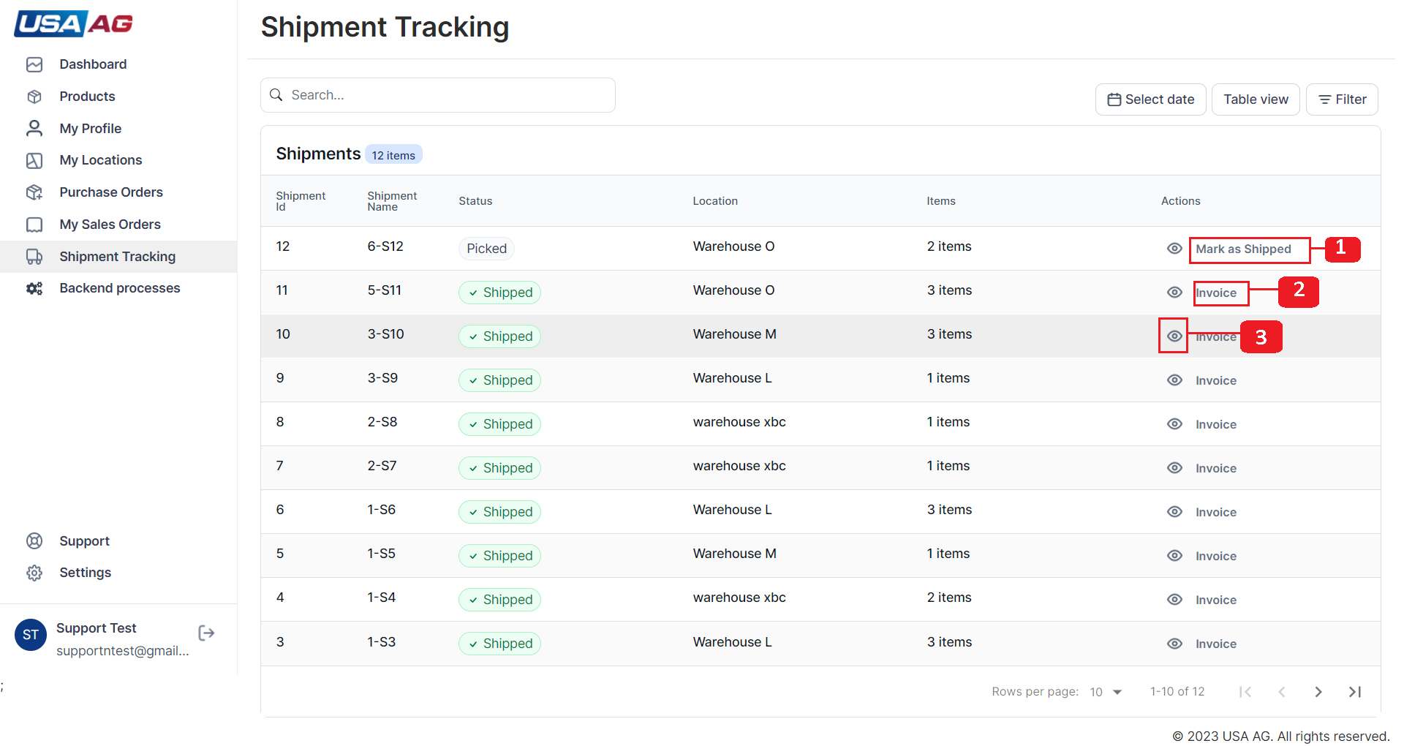  
Fig: 2 [Shipment list page.](http://192.168.1.168:3000/vendor/support/shipments)

**Change shipment status(Mark as shipped)?**

**Steps to Mark as Shipped**

On Mark as Shipped button clicked from shipment details or shipment Listing it opens modal form with fields listed below marked with points as shows in[Figure 1](http://192.168.1.168:3000/vendor/support/shipments):

1. Shows status field with shipped status selected.
2. Point one shows shipment name, Location and Carrier in card.
3. Tracking no field with required validation.
4. Tracking url with required starts with http:// or https://.
5. Comment textarea field.
6. Send mail notification to customer.
7. Save button to save form.
8. Shipment cost field with default $0.00 value.

Invoice preview is shown in[Figure 4](http://192.168.1.168:3000/vendor/support/shipments).

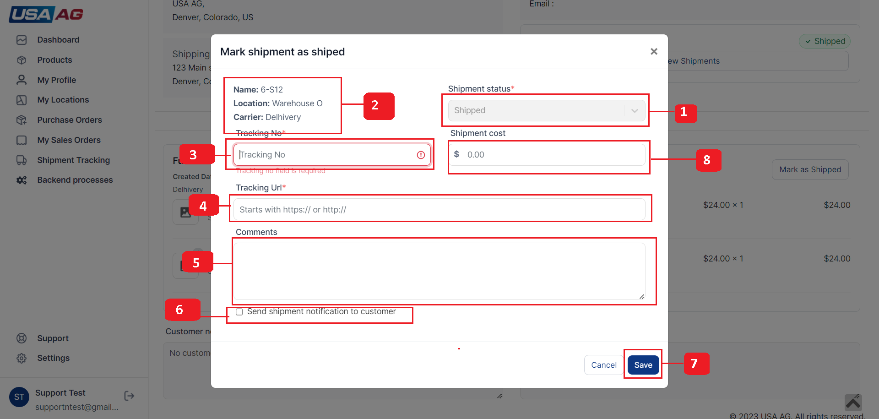  
Fig: 1 [Shipment list page.](http://192.168.1.168:3000/vendor/support/shipments)

**Generate Invoice?**

On Invoice button click it open Invoice modal. when the modal open it will fetch shipment data from api and then it shows two options as shown in [Figure 3](http://192.168.1.168:3000/vendor/support/shipments).

1. View and Print it opens Invoice in new tab in pdf format.
2. Download it download In voice in pdf format.

Invoice preview is shown in [Figure 4](http://192.168.1.168:3000/vendor/support/shipments).

**View shipment?**

**In the View Shipment page, you will find several elements as indicated by the numbered points in the**[**Figure 5**](http://192.168.1.168:3000/vendor/support/shipments)**. Here is a description of each point:**

1. Shows Shipment id.
2. Shows Shipment name.
3. Shows card for showing Shipment details like Carrier, Location, Send notification to customer, Shipping cost and Items count.
4. Shows Shipment name.
5. Shows Tracking no link with shipment url that opens in new tab.
6. Shows button that opens invoice generate modal. If the status is picked then it shows Mark as read button
7. Shows card for shipment with its items and other details.

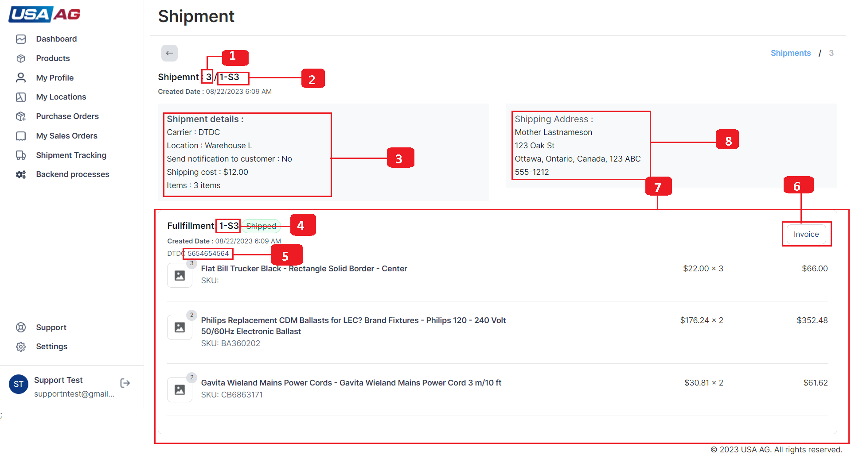  
Fig: 5 [Shipment details page.](http://192.168.1.168:3000/vendor/support/shipments)

**Orders Listing?**

**Orders listing styling is explained in Listing page you can refer to (**[**Listing page**](http://192.168.1.168:3000/admin/support/orders)**) with different columns, actions and filters explained below:**

1. Order listing table has columns Order(Order number), Date(Order date), Customer(Customer name), Total(total order amount), Payment status, Fulfillment status, Items(item count in order), Delivery method, Tags and Actions.
2. Order listing page has two actions View order details(navigate to details page) and Purchases(navigates to vendor-order page for order).
3. Order listing page has Search, Order Date ,Payment status and Fulfillment status filters as shown in [Figure 1](http://192.168.1.168:3000/admin/support/orders).

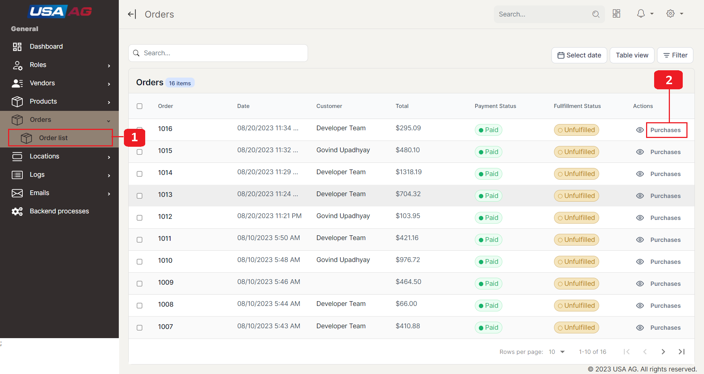  
Fig: 1 [Order Listing page.](http://192.168.1.168:3000/admin/support/orders)

**Purchases?**

**On clicking "Purchases" button indicated with point 2 in**[**Figure 1**](http://192.168.1.168:3000/admin/support/orders)**you will redirected to Vendor order purchases page as shown in**[**Figure 2, 6 and 7**](http://192.168.1.168:3000/admin/support/orders)**.Figure point are explained below:**

In [Figure 2](http://192.168.1.168:3000/admin/support/orders):

1. Navigation button to go to orders listing page.
2. Vendor name.
3. Status for purchase order.Status(Not created or order sent).
4. Breadcrumb link for orderlisting page.
5. Order Id for order in breadcrumb.
6. Note for order.
7. Customer note.
8. Navigation button for create purchase order page.

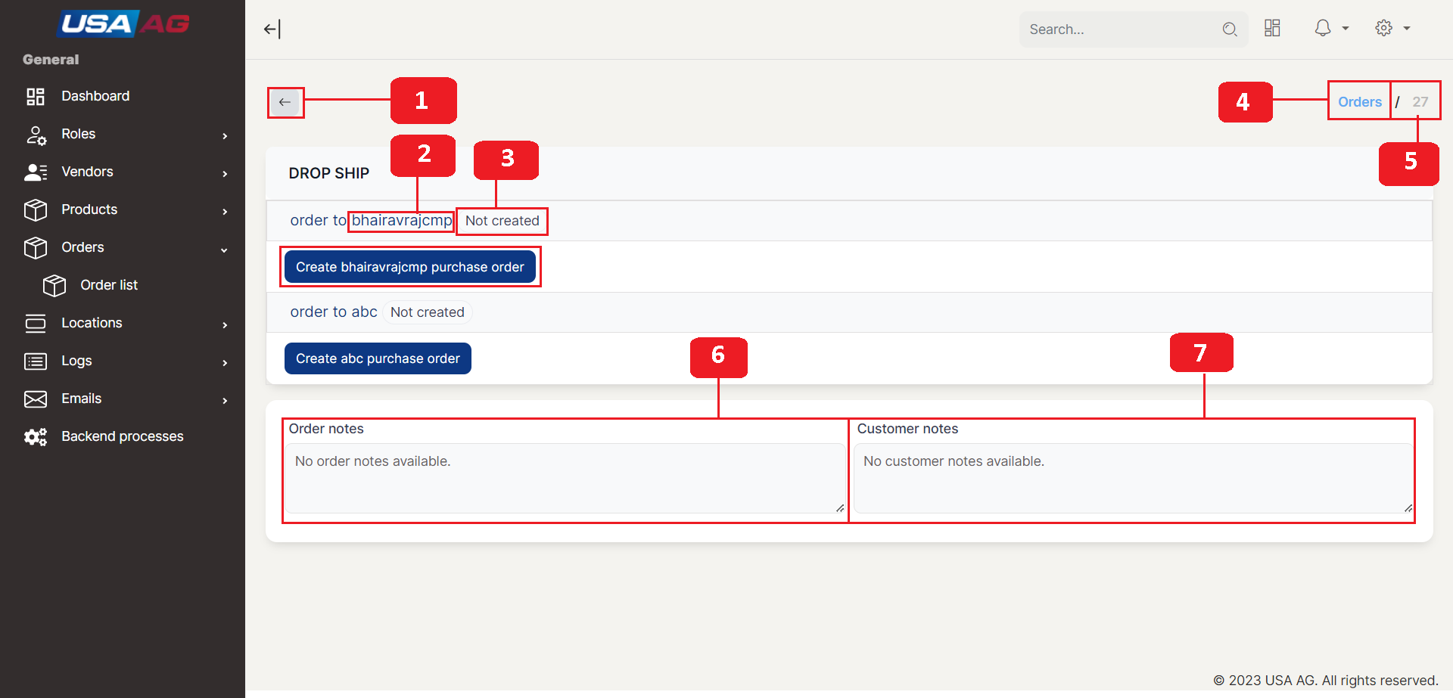  
Fig: 2 [Purchase page.](http://192.168.1.168:3000/admin/support/orders)

In [Figure 7](http://192.168.1.168:3000/admin/support/orders) if the order is created for vendor it will show button explained below:

1. Navigation button to goto edit purchase order page.
2. Open Modal to view Purchase order details.

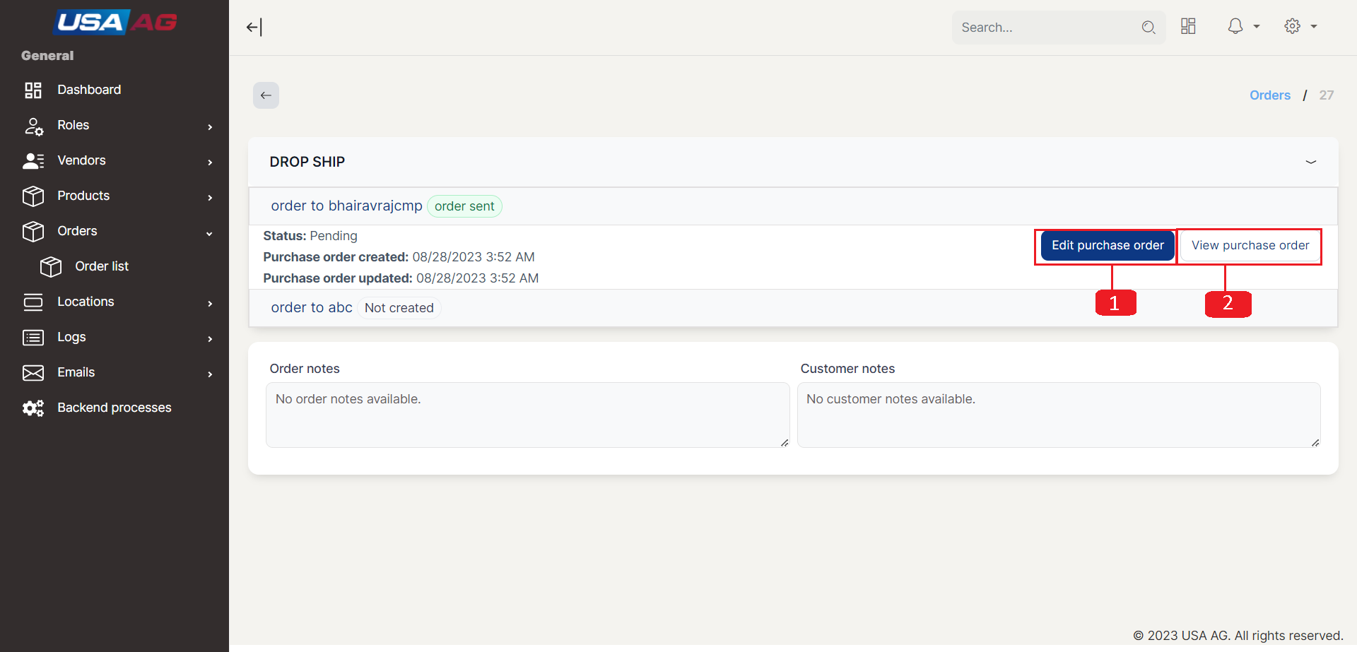  
Fig: 7 [Purchase page.](http://192.168.1.168:3000/admin/support/orders)

**Create purchase order?**

**On clicking "Create purchase order" it will open form as show in**[**Figure 3**](http://192.168.1.168:3000/admin/support/orders)**.Marked points are explained below:**

1. Text area for billing address it has default values filled. Field is required.
2. Text area for shipment address it has default value from order. Field is required.
3. Requisitioner(Po name) input with default value created with combination for order no, customer name and vendor id. Field is required.
4. "Add Item "It opens modal to add item in Purchase order. This form can be filled in two ways first selecting product from list and choosing its variant and second is manual filling. Fields are mentioned below and marked with points in [Figure 4](http://192.168.1.168:3000/admin/support/orders)
   1. Modal close icon.
   2. Item name field with required validation.
   3. Quantity min 1 and field is required.
   4. SKU field.
   5. Price filed default its value is $0.00.
   6. Product selection dropdown for selecting product from vendor products. On selection it will fill form automatically.
5. Comment for vendor.
6. Icon for editing item it will edit item modal as shown in [Figure 5](http://192.168.1.168:3000/admin/support/orders).points are mentioned below:
   1. Item name field with required validation.
   2. Quantity min 1 and field is required.
   3. SKU field.
   4. Price filed id disabled for edit.
   5. Modal Close button.
   6. Update button for update item.
7. Delete icon for removing item from list.
8. Checkbox for selection to remove multiple items at same item.
9. "Save" button on click it will save Purchase order and redirect to purchse page.
10. "Save & Preview" button on click it will save Purchase order and redirect to purchse page also open Purchase order detail modal on purchase page.

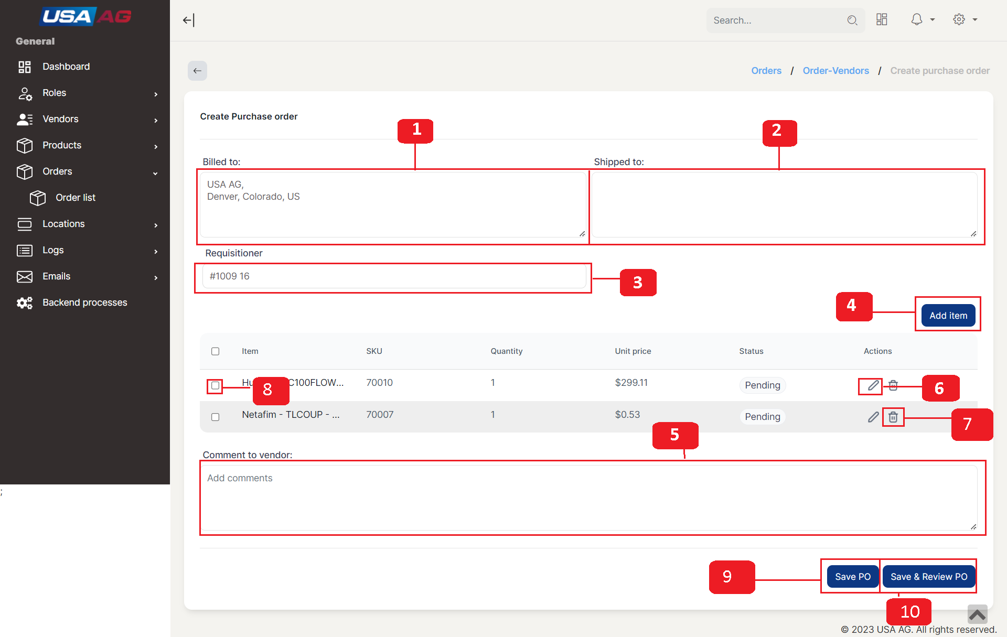  
Fig: 3 [Create Purchase order page.](http://192.168.1.168:3000/admin/support/orders)

**Edit purchase order?**

**Edit purchase order has same functionalities as Create purchase order form. But the Billed To, Shipped To, Requisitioner, and Comment are disabled if the purchase order is accepted by vendor and item are non editable if they are accepted.**

**View purchase order?**

On clicking "View purchase order" button on Purchase page it will open modal with purchase order details like Billed To(Billing address), Shipped To(shipping address), REQUISITIONER(purchase order name) and Item Listing(with Item no , Item name, sku, quantity and unit price). Purchase order details modal had one button pointed with point 1 in[Figure 8](http://192.168.1.168:3000/admin/support/orders) on click it will genrate pdf and download it as shown in[Figure 9](http://192.168.1.168:3000/admin/support/orders).

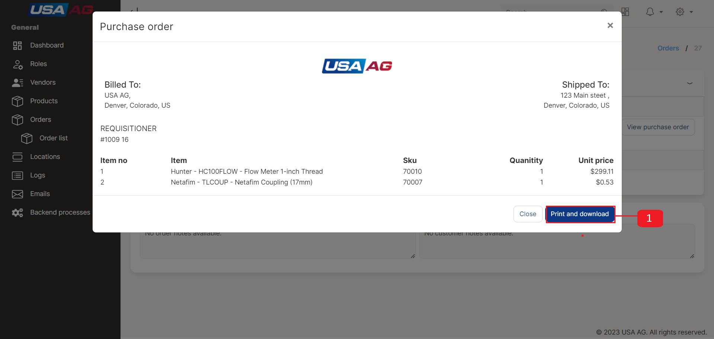  
Fig: 8 [Purchase order details modal.](http://192.168.1.168:3000/admin/support/orders)

**Registering a Vendor?**

**Login page has link "Apply for vendor account" on click it redirects to Vendor registration page.Login page is Shown in**[**Figure 5**](http://192.168.1.168:3000/admin/support/vendors)**. Vendor registration is an step form explained below by steps:**

**1**

Registration step 1 has three fields 1.)First name(field is required), 2.)Last name(field is required) and 3.)Email(field is required). On continue click it will take to new step for registration. On Left side of form it has Steps defined for registration. You can go back to last steps by clicking icon on step. There is also a link for log in if the user already account.

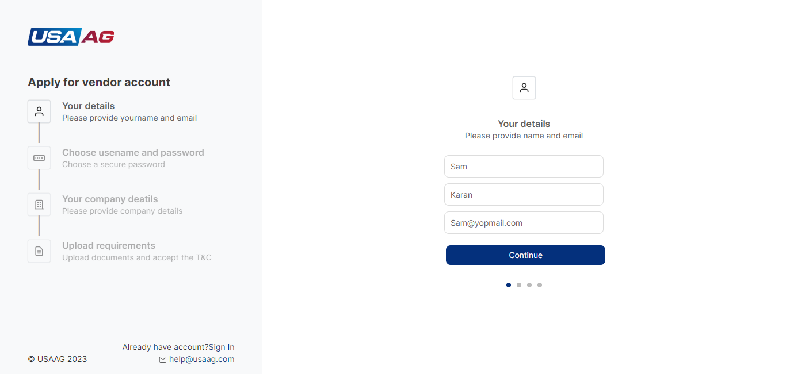  
Fig: 6 Vendor Registration step 1

**2**

Second step has fields like 1.)User name(this field is required and can only contain letters, numbers, underscores, and hyphens.), 2.)Password(Password length must be at least 8 characters. and it has eye icon to see password) and 3.) Confirm password(Confirm password length must be at least 8 characters. and matches with Password value).

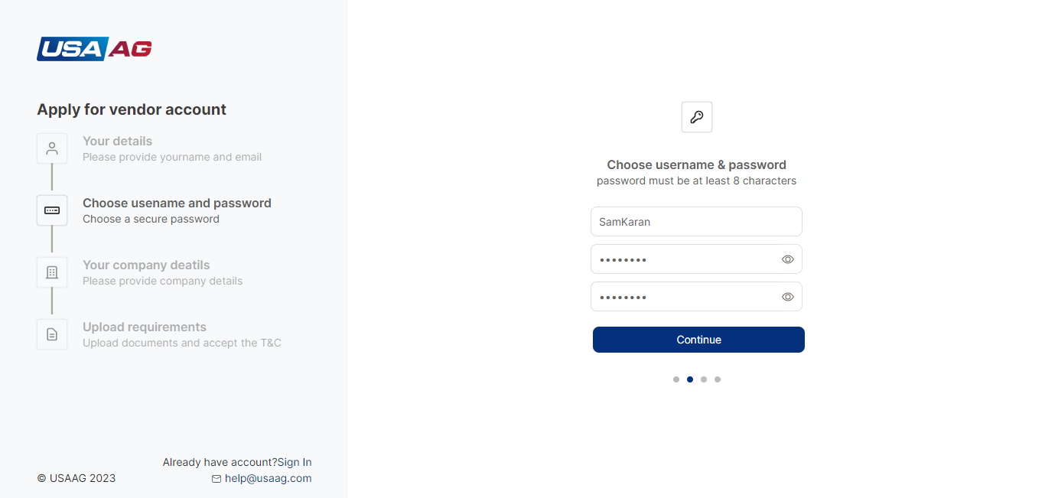  
Fig: 7 Vendor Registration step 2

**3**

Third step has fields like 1.)Company name(this field is required), 2.)Telephone no(This field is required, it must be written in format Country code + no and it does not contains other characters like space,dash ,etc) and 3.)Address(Field is required).

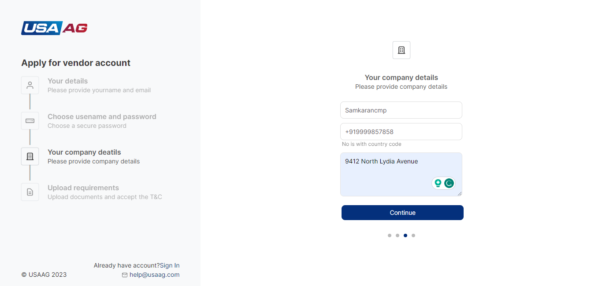  
Fig: 8 Vendor Registration step 3

**4**

Fourth step has fields like 1.)W-9form(on click "Click to upload" it open file upload, file must be image any type and its size must be under 1280*720)and 2.)Accept terms and condition check box(Check is required and on link click it opens terms and condition page in new tab).  
  
On Submit click it submits form and redirect to success page with Resend confirmation mail link and log in link shown in [Figure 10](http://192.168.1.168:3000/admin/support/vendors). After submit User will receive and mail for confirmation. On confirmation link clicked it will confirm the link. After Approved by admin user can login with its vendor account.

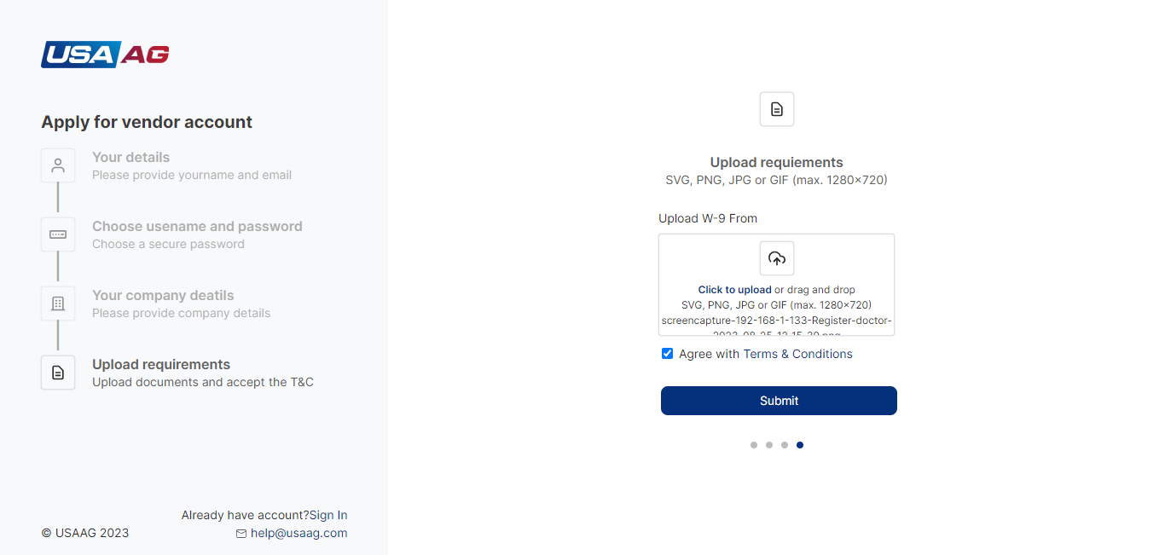  
Fig: 9 Vendor Registration step 4

**Vendor Listing?**

**In this list Vendors are shown will been approved or disapproved from Vendor Request listing. Vendor listing styling is explained in Listing page you can refer to (**[**Listing page**](http://192.168.1.168:3000/admin/support/vendors)**) with different columns, actions and filters explained below:**

1. Vendor listing table has columns Id(Vendor Id), Company Name, Name(First name with Last name), Email, Telephone no, Address Status(Active and In active), and Actions(View Vendor, Allow Vendor(if Blocked) and Block Vendor(if Allowed)).
2. Vendor listing page has Search, ,Status, Company name and Address filters as shown in [Figure 2 and 4](http://192.168.1.168:3000/admin/support/vendors).

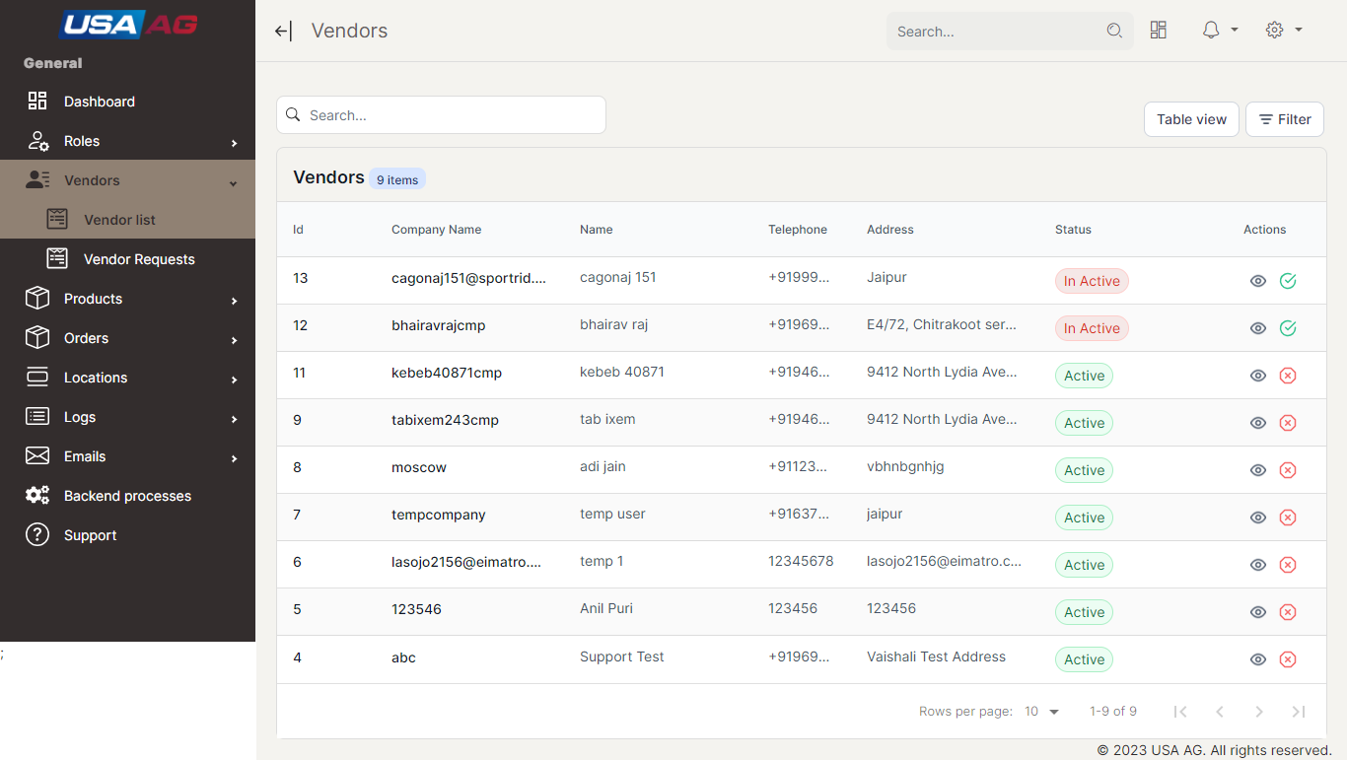  
Fig: 4 [Vendor Listing page.](http://192.168.1.168:3000/admin/support/vendors)

**Vendor Requests?**

**When the Vendor is registered it will show in Vendor request list but after Approving or Disapproving it will move to Vendor listing. Vendor Requests styling is explained in Listing page you can refer to (**[**Listing page**](http://192.168.1.168:3000/admin/support/vendors)**) with different columns, actions and filters explained below:**

1. Vendor Requests table has columns Id(Vendor Id), Company Name, Name(First name with Last name), Email, Telephone no, Address Date, and Actions(View Vendor, Approve Vendor and Disapprove Vendor).
2. Vendor Request page has Search, ,Created Date, Company name and Address filters as shown in [Figure 11 and 12](http://192.168.1.168:3000/admin/support/vendors).

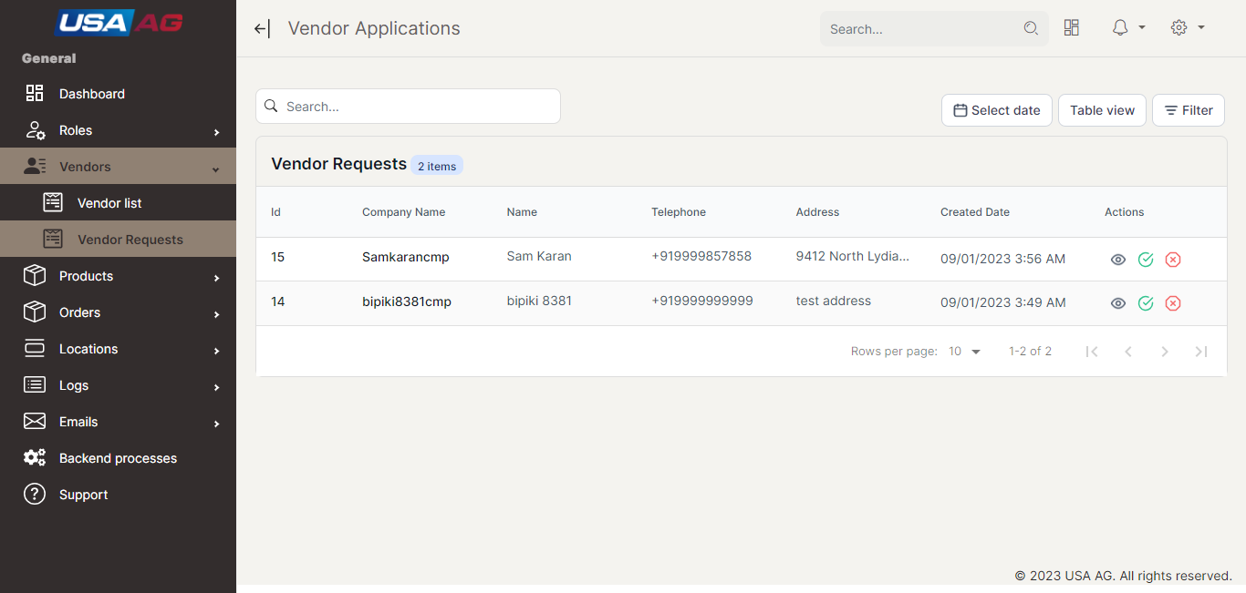  
Fig: 11 [Vendor Requests page.](http://192.168.1.168:3000/admin/support/vendors)

**Approving and Disapproving Vendor?**

**In Vendor Request page you can see two action 1.)Approve(with green check icon) and 2.)Disapprove(with red cross icon). With out approve of vendor it is not allowed to login. On icons clicked they will perform their corresponding action like Approving and Disapproving.**

**Allowing and Blocking vendor?**

**In Vendor Listing page you can see two action 1.)Allow(with green check icon) and 2.)Block(with red cross icon). With out Allowed of vendor it is not allowed to login. On icons clicked they will perform their corresponding action like Allowing and Blocking.**

**Vendor details modal?**

In vendor details modal it shows vendor details like Name, Email ,Company Name, Telephone no(it will open tel link in new tab) ,Address(it will open it in map in new tab) , created date , updated date , status and view W-9 from(open file in new tab) for vendor.

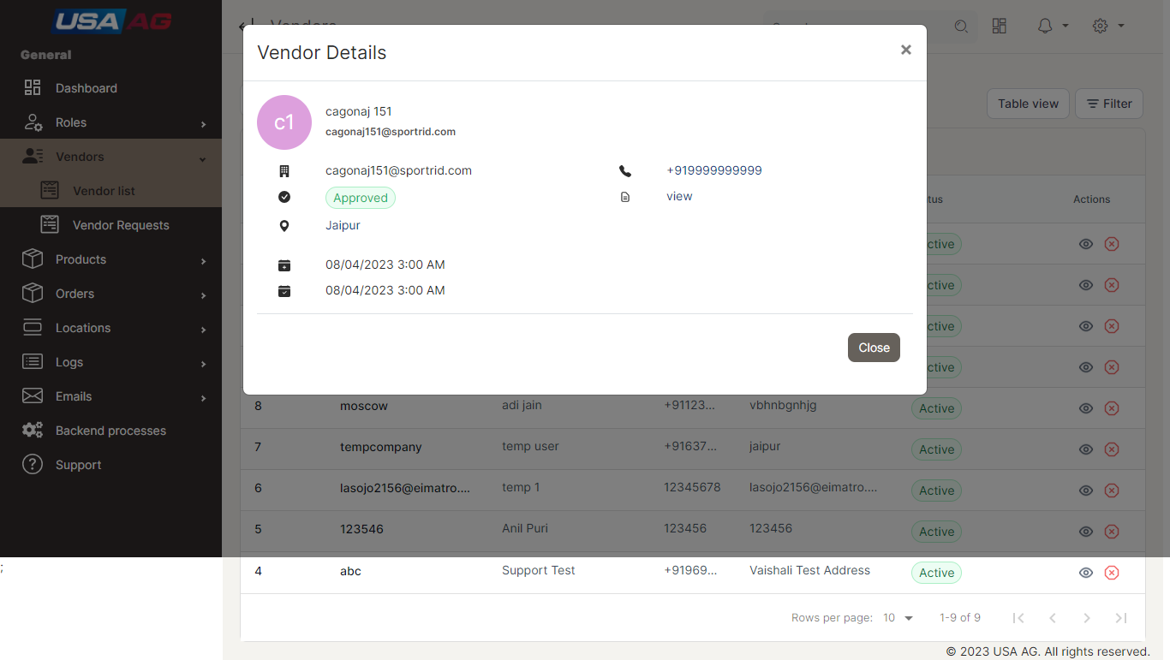  
Fig: 3 [Vendor Details Modal.](http://192.168.1.168:3000/admin/support/vendors)